Reading Bands Information
In Key Stage 1 at Edward Feild, children are provided with a phonetically decodable book per week that is suitable for their level and links in with the phonics that they are currently learning at school. The reading books are graded by reading levels known as Book Bands, and also state which phonics phase and sounds are within the book. We use a variety of schemes to form the basis of our book banding.

Book Bands and Expectations Chart
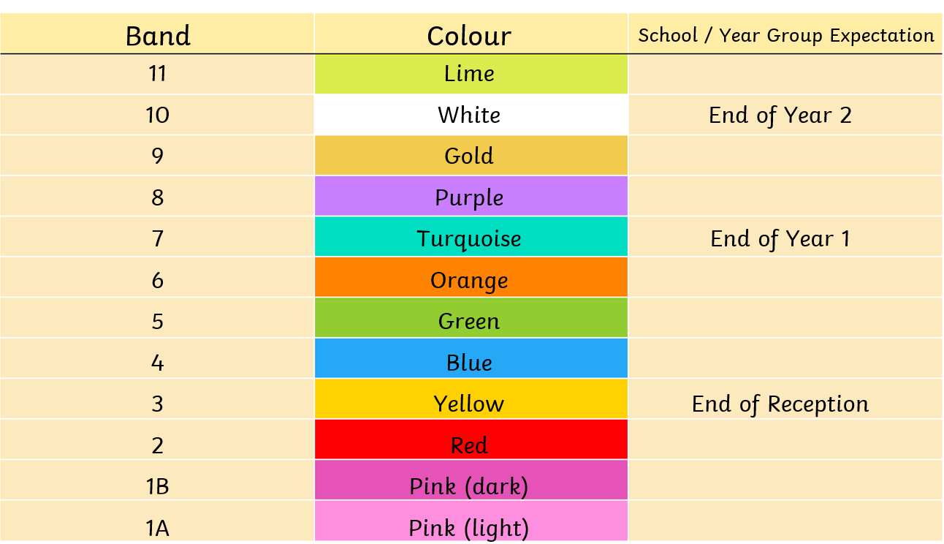

Each Book Band has its own colour. The chart also gives an idea of the year group expectation. At the end of Year 1, it is expected that children will be reading Turquoise banded books. At the end of Year 2, it is expected that children will be reading White banded books.

How We Assess Your Child’s Reading Level
There are a number of ways in school in which teachers decide which Book Band is appropriate for your child. The children are listened to reading, their reading ages are calculated, and they are also tested on their comprehension. As a rough guidance, children should be able to read 90% of the words on the page fluently to be reading the correct colour band. Progress through the bands is not automatic and children need to show an improvement in their fluency and accuracy with reading up to 98% of the words fluently, as well as a secure understanding of what they are reading, to progress to the next colour band.
How to Support your Child at Home
In this challenging time when teachers are not able to change the children’s reading books, we strongly encourage you to continue to listen to your child read for 10 – 15 minutes per day. When reading with your child, support them with any words they find challenging, helping them to decode and blend the word. Also talk to them about any tricky vocabulary, helping them to unpick the word, define it and put it into a sentence. We have also provided reading comprehension bookmarks on our Online Classroom page of the website – try to ask your child a question from each content domain when reading to support them with their comprehension.

There are many phonetically decodable e-books that can be found online so that over this period of school closures, you can ensure your child is reading books of the correct level and progressing through the Book Bands.

https://home.oxfordowl.co.uk/books/free-ebooks/

On the Oxford Owl website, you can browse the books by Oxford Level. For example, Level 6 is equivalent to the Book Band ‘Orange’.

https://collins.co.uk/pages/big-cat-ebooks

On the Collins Big Cats website, you can also browse the books by band level. There are also free downloadable worksheets for each book band to use alongside the books.

If you need any further support with reading with your child at home, which Book Band they should be on, or further comprehension support, please don’t hesitate to email your child’s teacher.

