Carrot Top Growing Experiment

*What you need;

Carrots
Water
Bowl or plate.

How to grow carrot tops from carrots

- Cut the top off a carrot you only need the top part and can eat the rest.
- Place carrot top in a little water in your bowl.
- Check progress after a few days and a few tiny shoots will have appeared.
- Add a little water every day if its running low and see how the green top grows.

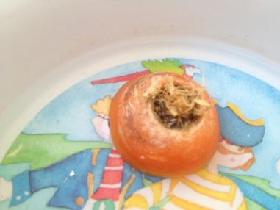

This Photo by Unknown Author is licensed under CC BY-NC-ND

