Instructions:
- Try to find out what the 3D shapes are called
- Have a look around the house and see how many ‘real life’ 3D shapes you can find which are the same as these ones!
- You can then either write or draw the household objects into the third column
3D Shape | What is it called | Household objects
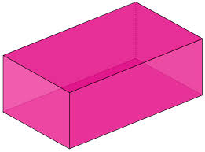

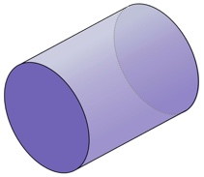

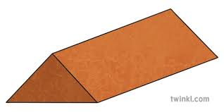

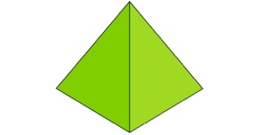

Super Challenge

If you still have time – see if you can count how many faces each of these 3D shapes have!

