sail



[This Photo](https://www.flickr.com/photos/30478819@N08/50017872521) by Unknown Author is licensed under [CC BY](https://creativecommons.org/licenses/by/3.0/)

pain

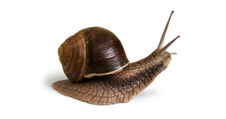

[This Photo](https://ictevangelist.com/dont-use-technology-use-technology-2/) by Unknown Author is licensed under [CC BY-NC-ND](https://creativecommons.org/licenses/by-nc-nd/3.0/)

tail 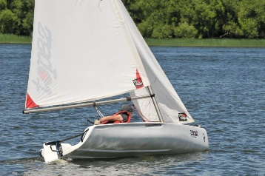

snail



[This Photo](https://ejournal4writing.wordpress.com/tag/action-verbs/) by Unknown Author is licensed under [CC BY-SA-NC](https://creativecommons.org/licenses/by-nc-sa/3.0/)

paint

