Week ending 11th December

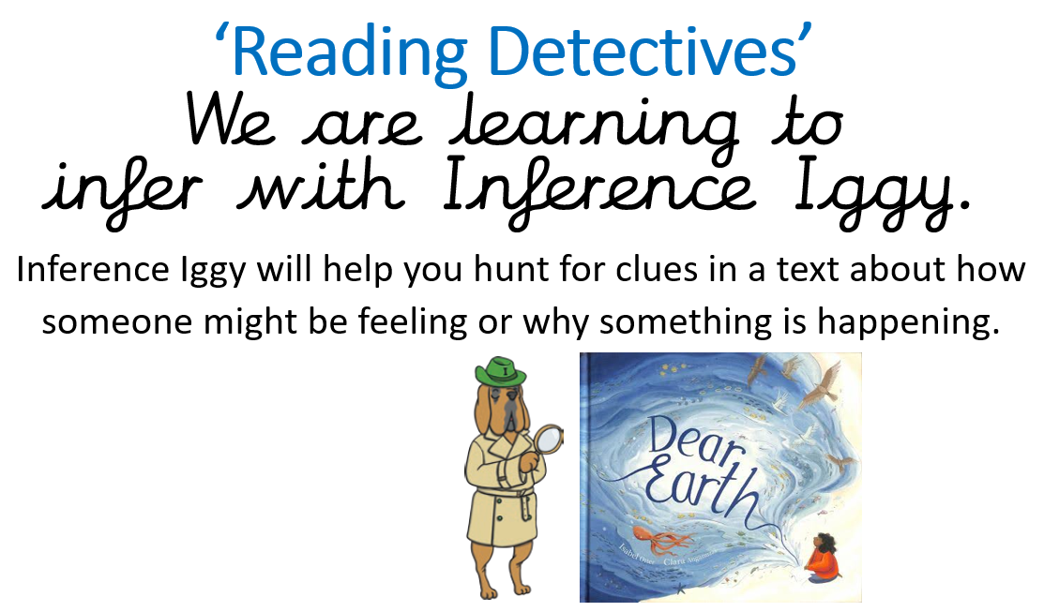

Activity 1

Can you read our vocabulary words and meanings this week? Can you put the vocabulary into a sentence?

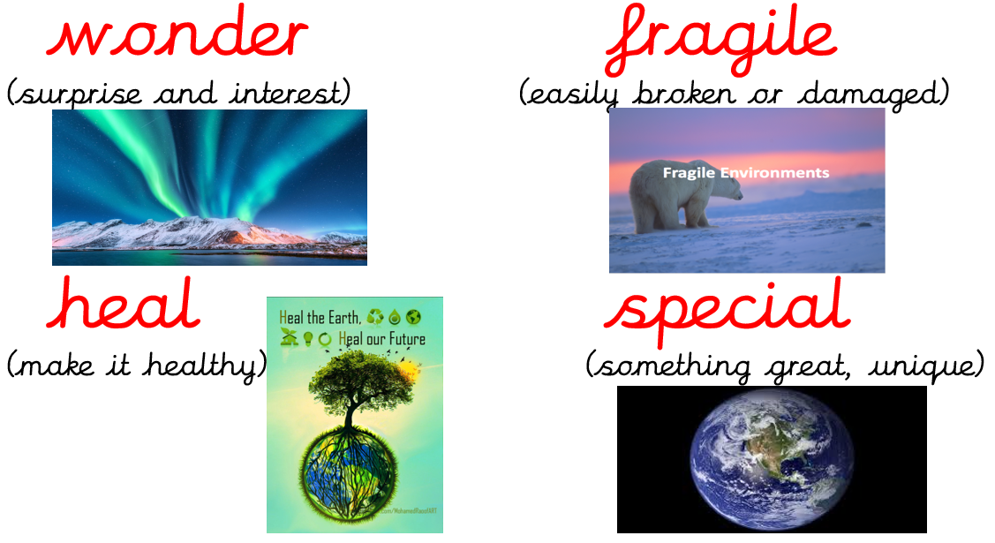

Activity 2

Read the page below.

What does Tessa mean?

1. 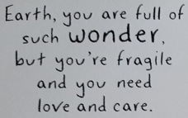 b) 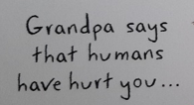

Activity 4

Create a mind map for how we can heal Earth’s environment.

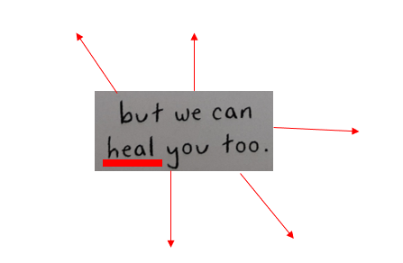

Activity 5

Read the pages below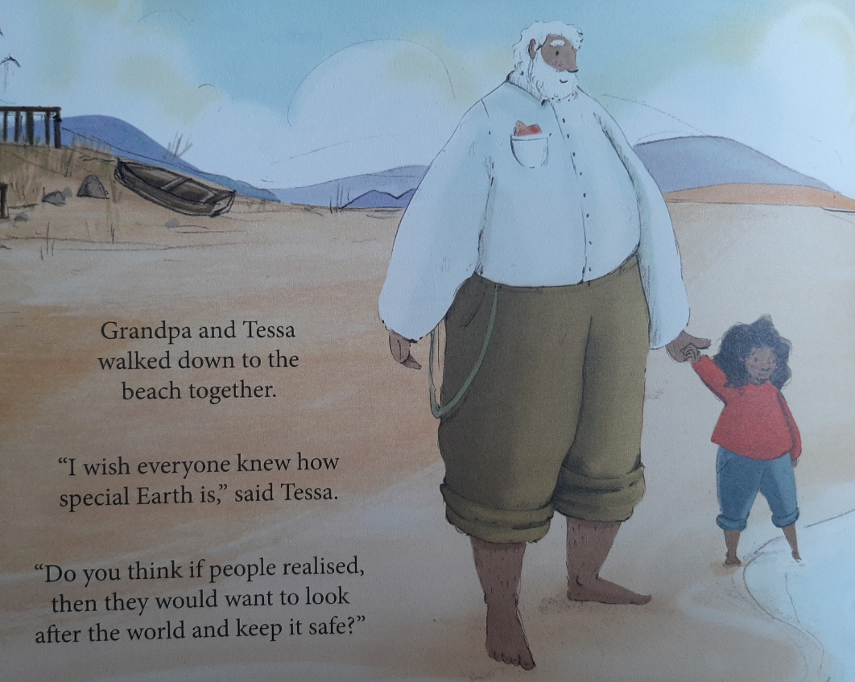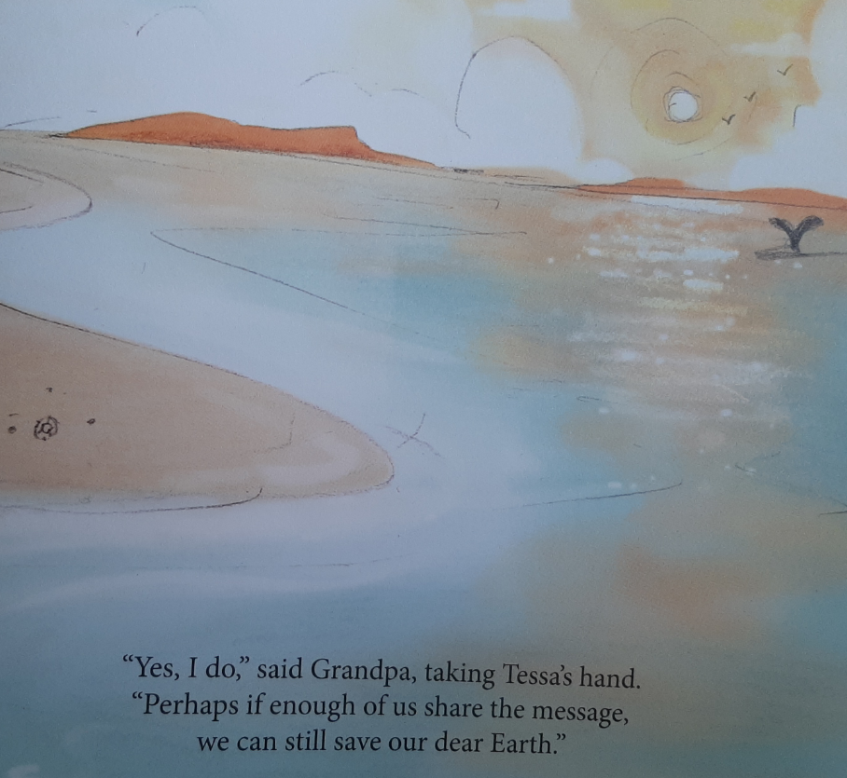

Why does Tessa write a letter?

*Tessa writes a letter because …*

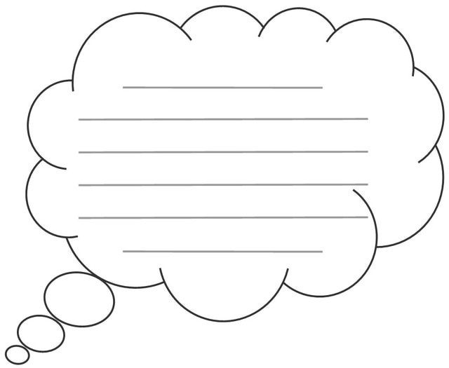

Challenge - Can you include any key vocabulary?

*wonder fragile heal special*