1. Watch the video then write the words for the pictures, remember to use the correct letter formation.
2. <https://www.youtube.com/watch?v=2ncQwQZJ47E>

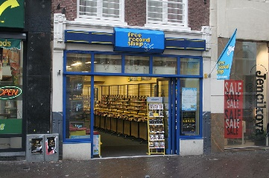

[This Photo](https://en.wikipedia.org/wiki/Record_shop) by Unknown Author is licensed under [CC BY-SA](https://creativecommons.org/licenses/by-sa/3.0/)

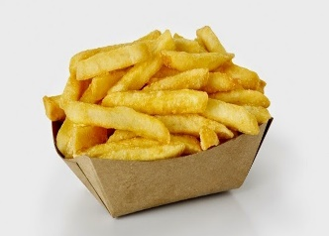

[This Photo](http://cabbagesofdoom.blogspot.com/2015/02/aussie-vs-britishirish-fish-n-chips.html) by Unknown Author is licensed under [CC BY-SA](https://creativecommons.org/licenses/by-sa/3.0/)

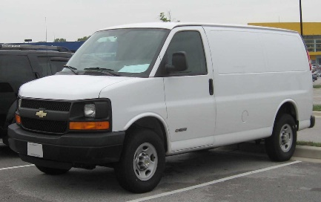

[This Photo](http://commons.wikimedia.org/wiki/File:Chevrolet-Express-Van.jpg) by Unknown Author is licensed under [CC BY-SA](https://creativecommons.org/licenses/by-sa/3.0/)

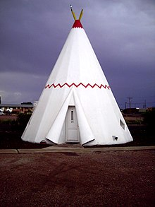

[This Photo](https://en.wikipedia.org/wiki/Wigwam_Motel) by Unknown Author is licensed under [CC BY-SA](https://creativecommons.org/licenses/by-sa/3.0/)