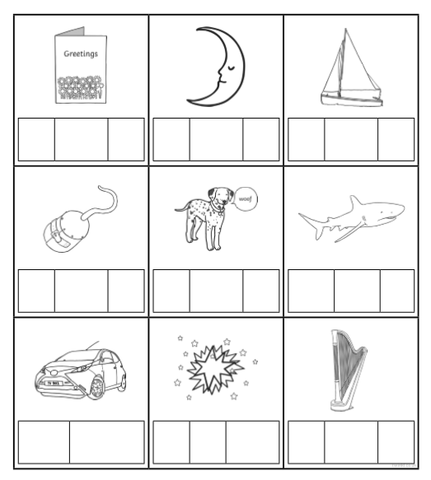
Have a look at the pictures.
Can you write the words in the phoneme frame to match?
Remember: one phoneme per box.

