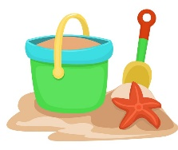  Science  https://www.youtube.com/watch?v=2dyCe1GPagE  Floating and Sinking  Fill a bowl with water and try testing different objects in your house to see if they float or sink. Make a prediction first and see if you were right. You could make a table like the one below.  https://www.bbc.co.uk/bitesize/clips/zmxqxnb  Animals that live in the sea.  Watch this clip about the creatures of the sea. You could draw a picture or make a model of one of the animals, or you could choose one to research and make a poster to show all the information you have found. |  | History  Watch these clips about how people used to enjoy holidays at the seaside  https://www.youtube.com/watch?v=exFmcLMjKsw  Magic Grandad Seaside Entertainment.  https://www.youtube.com/watch?v=zWgnpY4L9so  Magic Grandad the Beach  https://www.youtube.com/watch?v=RZlL77ZfXkI  Magic Grandad the Promenade  You could interview someone (maybe phone an older relative) to find out how they used to spend their holidays. What was the same and what is different to your holiday?  You could imagine you have been on holiday to the seaside in the past and write a diary entry about what you saw and what you did.
Craft  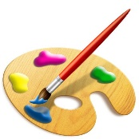  There are lots of fun ideas on the following pages for you to try. | 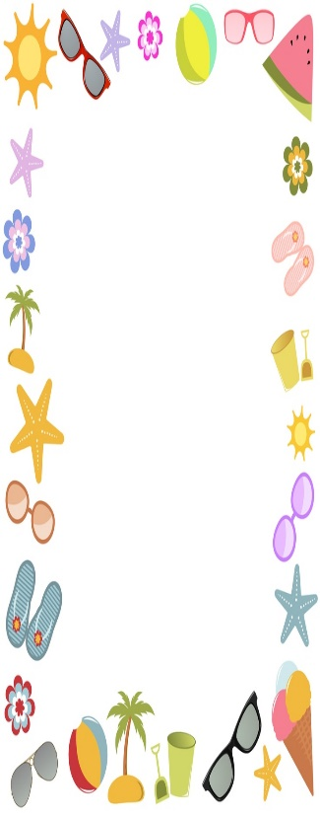  The Seaside
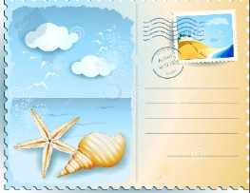
Art
Draw a picture of a seaside scene for a postcard. What will you draw to make people want to come to the beach? You could use pens, paints, crayons, pencils or any other materials you have at home.

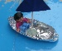
Design and Technology
Can you make a floating boat from tinfoil or other materials at home that a toy can sit in?
Design a t-shirt to wear to the beach.
Geography
See the image of a seaside town below. You don’t need to print the picture. Talk about the features of the seaside. Would you like to visit? Why? Why not? Which of the features are physical features (found in nature) and which are human features (made or built by people)?

https://www.youtube.com/watch?v=q-up6zuCQQg
A video about the 5 oceans in the world. Can you learn their names? You could make a fact file or a poster about one of the oceans.

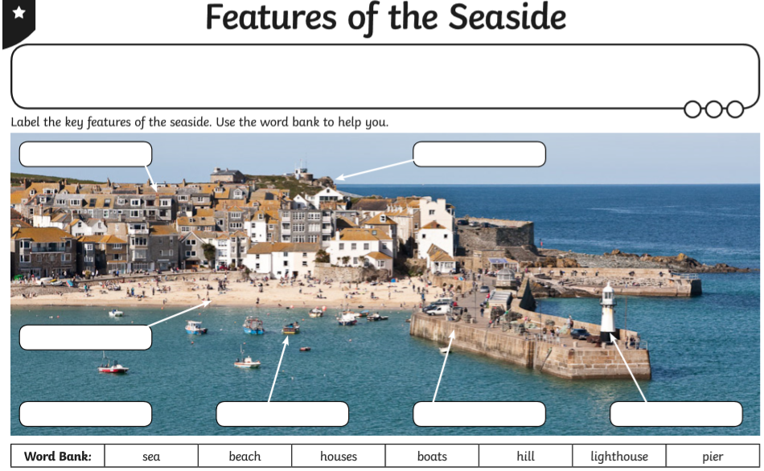

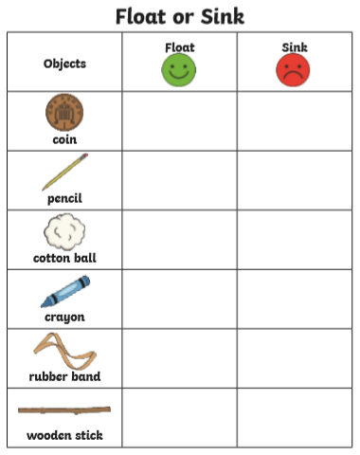
You could look around your home for these objects or choose some of your own.

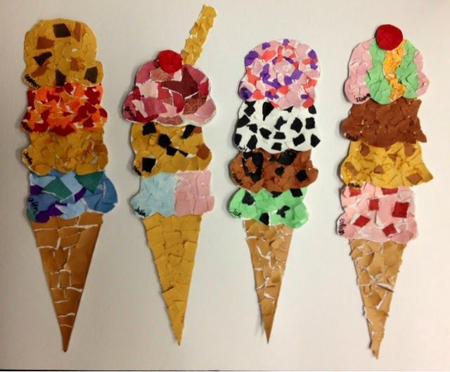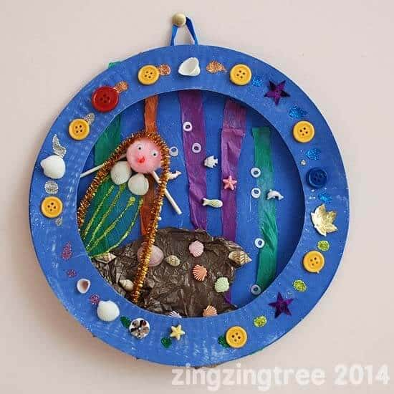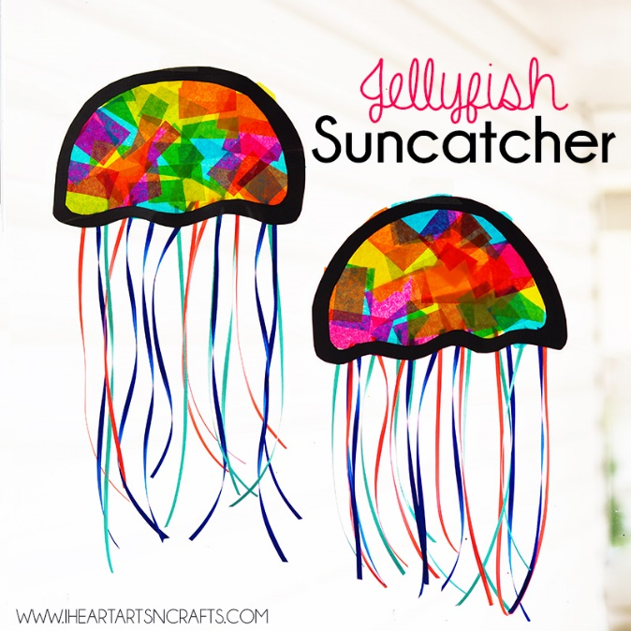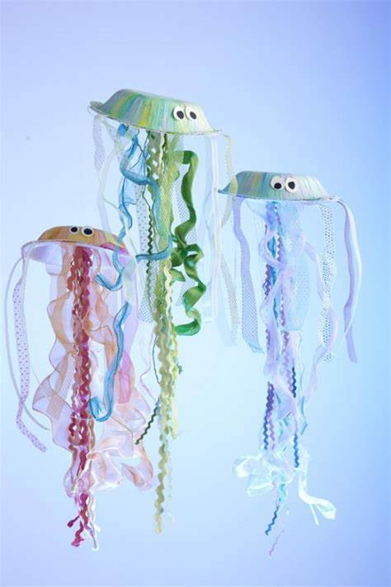
Please share your work with us on twitter or email it to your teacher.

