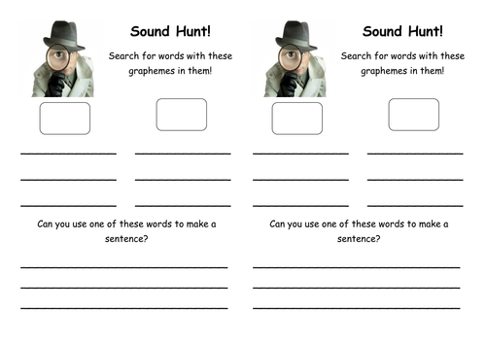

Back To the Moon Book

igh

ur

oa

Ow



Wants and Needs

er

ee

sh

oo



Fire Safety

ck

ur

ay

th