Year 2 Phonics - Week 2 (01.03.21) Adding -ed and -er to Words Ending in e

You do not have to print these sheets. You could write your answers on a piece of paper or point to the answers on the screen.
This week's spellings, learn them for the spelling test.
hiked, timed, braved, baked, hiker, timer, braver, baker, again, most

Monday 1st March
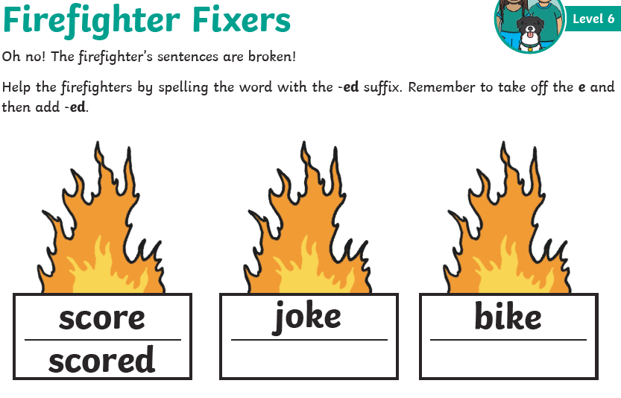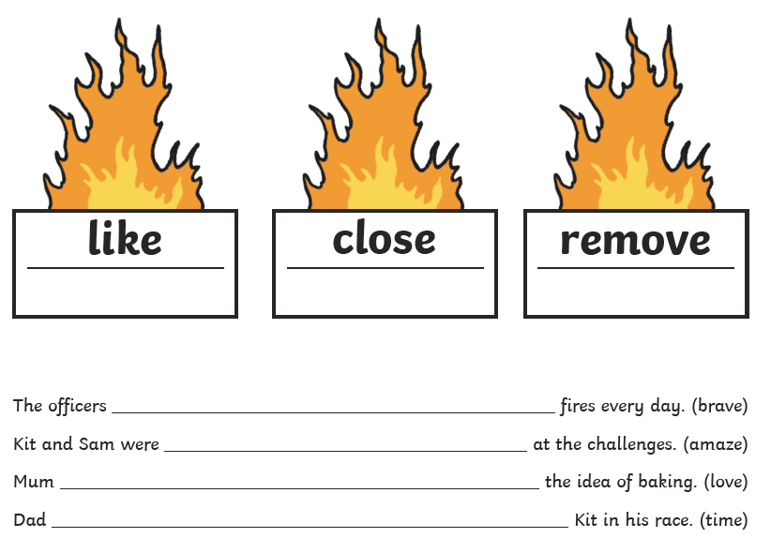

Monday challenge
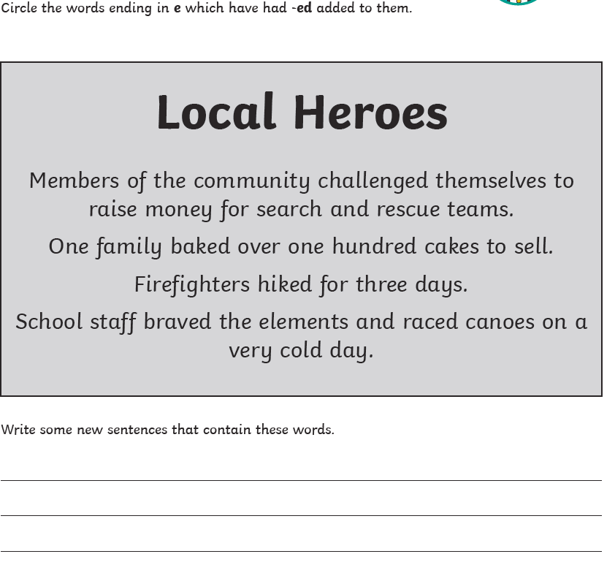

Tuesday 2nd March
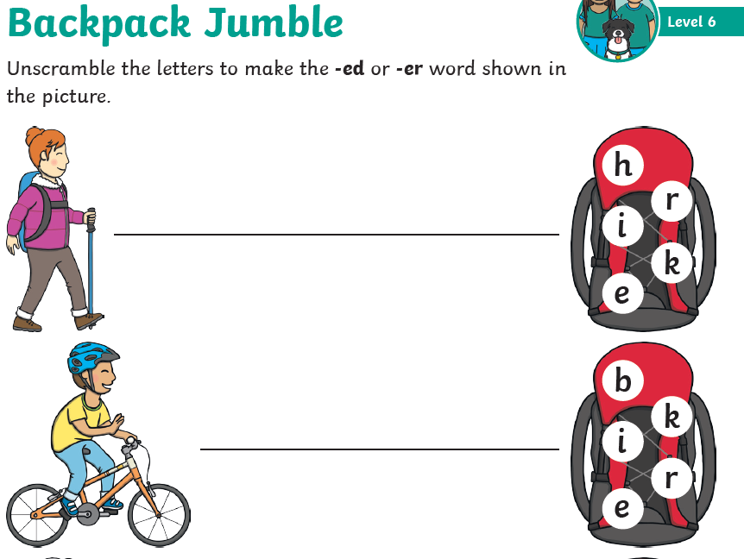#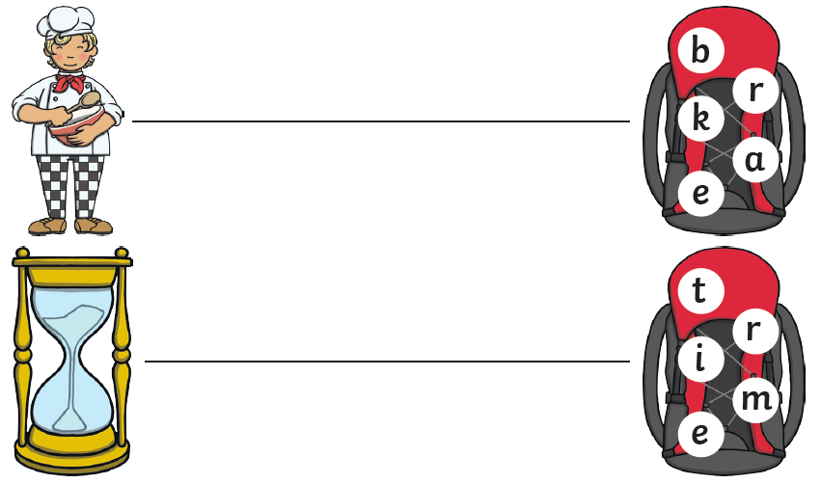

Tuesday challenge
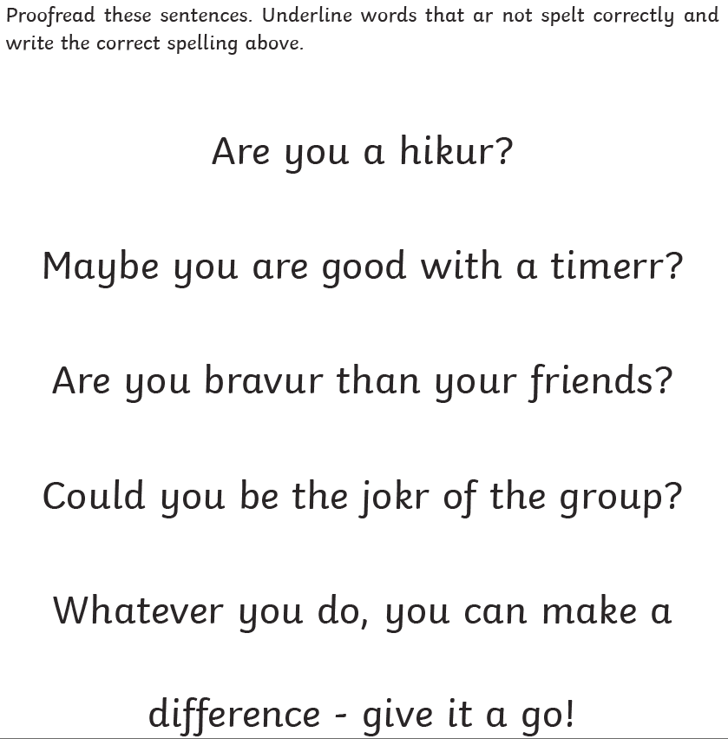

Wednesday 3rd March
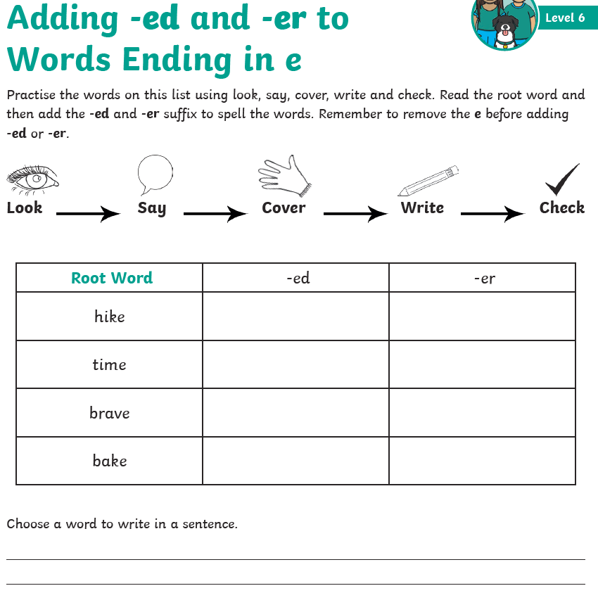

Do you know these spellings?
hiked, timed, braved, baked, hiker, timer, braver, baker, again, most

Wednesday Challenge
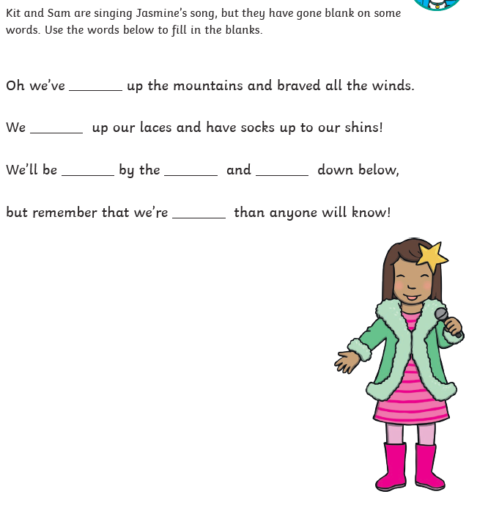

Thursday 4th March
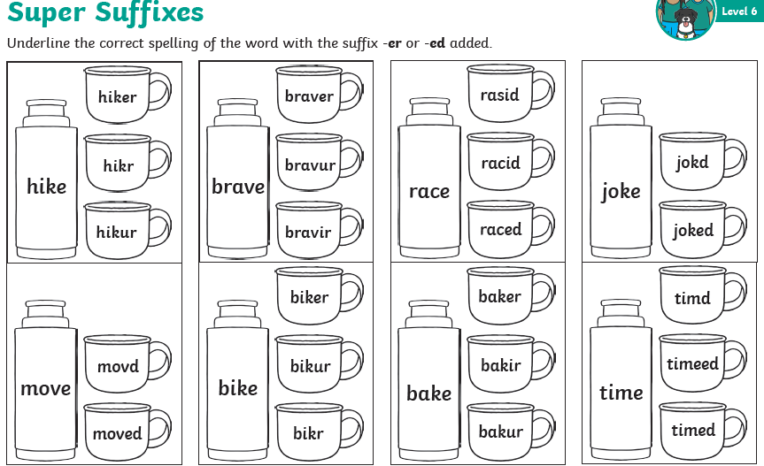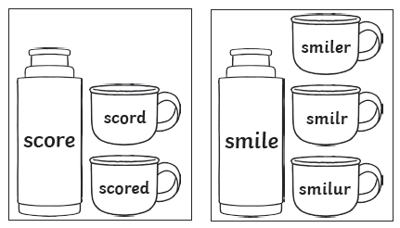

Thursday Challenge
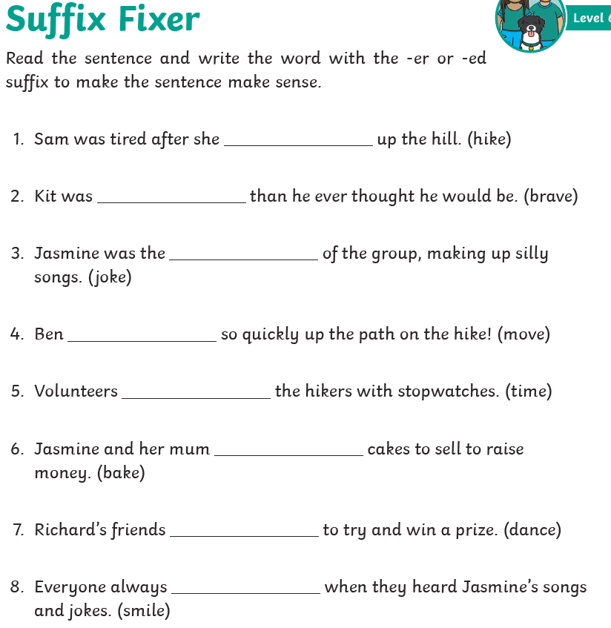

Friday 5th March - after watching the video you could have a go at any phase 5 game on phonics play or you could put all of this week's spelling words into a sentence.

