Complete the word with the new digraph, th, what does it say?

mo___

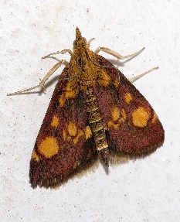

[This Photo](https://en.wikipedia.org/wiki/Mint_moth) by Unknown Author is licensed under [CC BY-SA](https://creativecommons.org/licenses/by-sa/3.0/)

___ick.

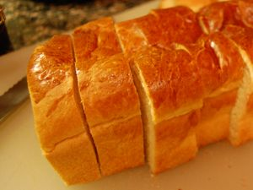

[This Photo](http://www.shinshine.com/my-blog/2010/09/stuffed-french-toast.html) by Unknown Author is licensed under [CC BY-NC-ND](https://creativecommons.org/licenses/by-nc-nd/3.0/)

3 ___ree

 __ink

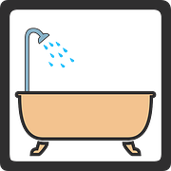 ba___