**The Enormous Crocodile’s Clever Tricks**

**Clever Trick Number One**

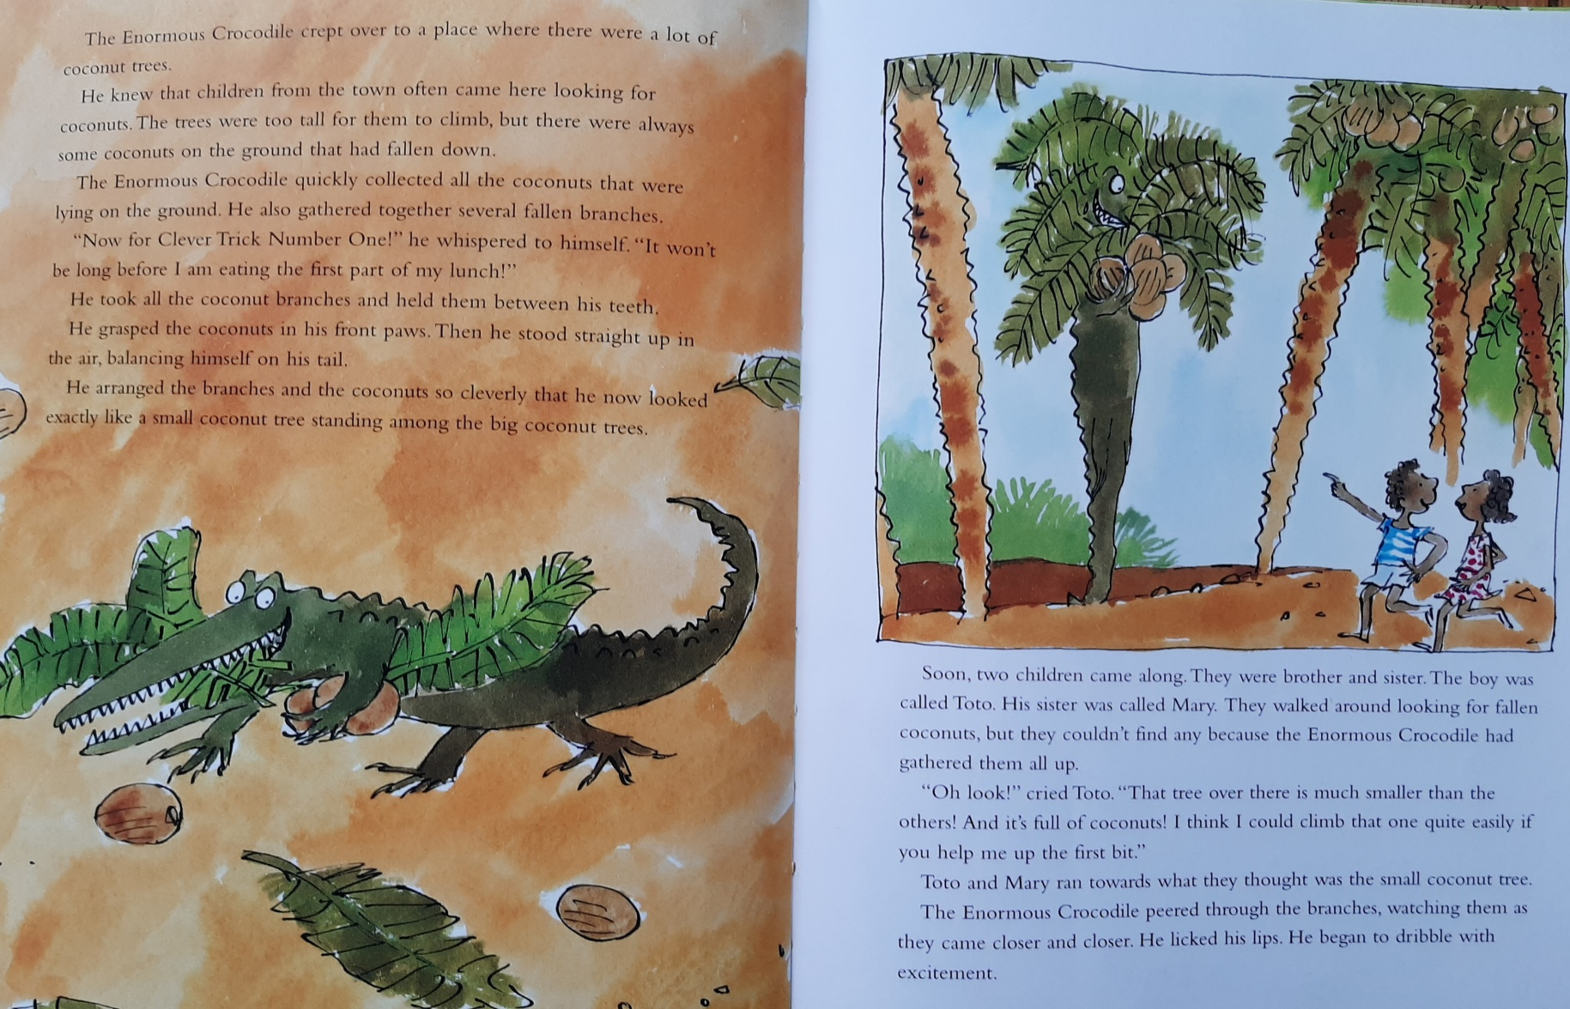

**Clever Trick Number Two**

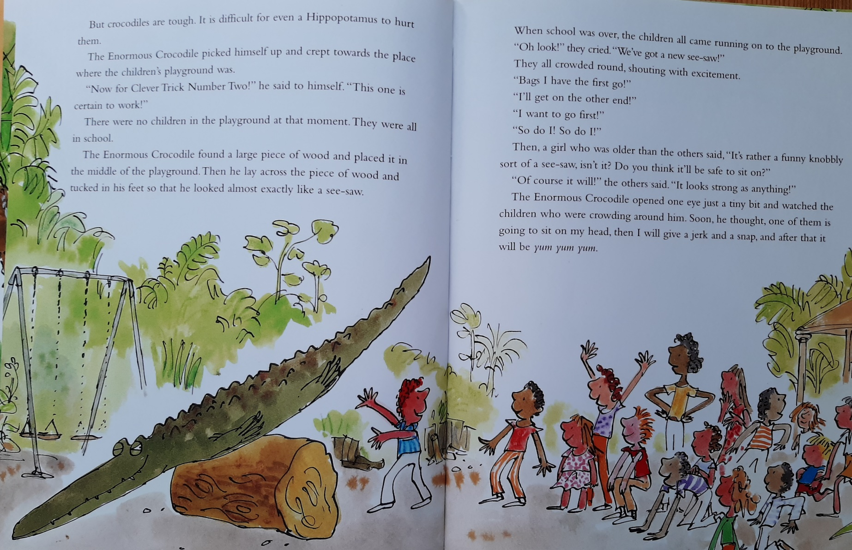

**Clever Trick Number Three**

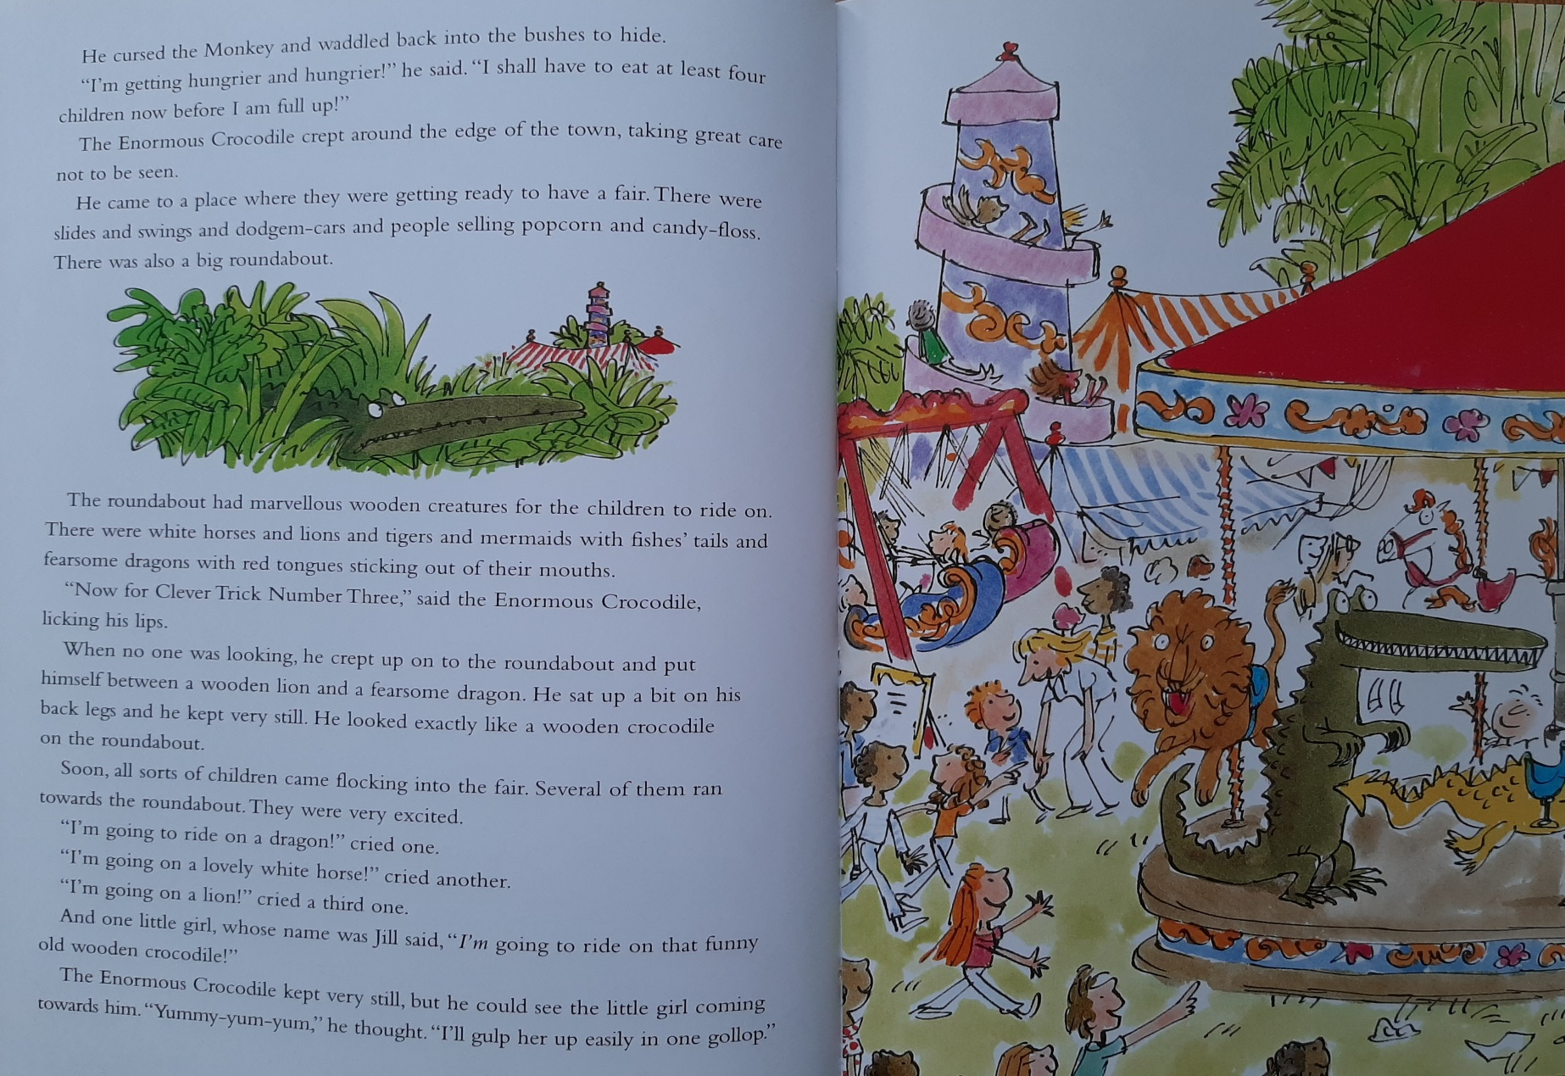

**Clever Trick Number Four**

