Thursday

First join your google meeting for todays digraph z, zz

Now complete the activity below, if you do not have a printer write the sentences on paper and read.

Read the following sentences and fill in the blanks making sure it makes sense.

I _______________________ up my coat.

The dogs fur is very ___________

She can draw a _______________.

A _________ is black and white.

We like to dance ___________.

Choose a word to fit the sentence.;

Zigzag zip zebra fuzzy buzz jazz

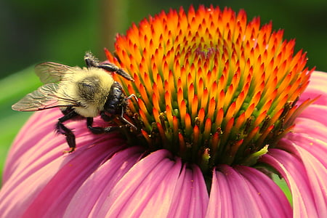

Can you write a sentence for the picture. Can you include buzz, wings in your sentence. Remember to try and think of one yourselves, use the writing guide on the web site to help you. Think it, Say it, Find the number of words, find the first word and write it.

Think about spacing your words.

