When writing a sentence: think about what you want to write, say it aloud, does it make sense?
How many words? Then find the first word and write it using robot talk if you need.

Can you write a simple sentence using digraph oa?

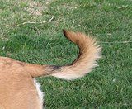 Can you write a simple sentence using the digraph ai?

Can you write a simple sentence using the ar digraph?

