Topic Activities

Complete the frog life cycle sheet or make your own. Draw each stage and label.

Make a minibeast friend!
- A spider – you will need: a toilet roll/kitchen roll tube, sticks/piper cleaners/paper for the legs and googly eyes (or draw your own).
- A ladybird – Paint a paper plate red and add some black spots.
- A butterfly – fold a piece of paper and open it back out. Paint on one side and then fold the paper to print a symmetrical pattern on the other side: just like a butterfly!
- A worm – fill a sock with old newspaper/tissue, add some eyes.

Paint a minibeast on stones.

Read fiction/non-fiction books about minibeasts – e.g. Superworm, The Ladybird That Heard, The Very Hungry Caterpillar, etc. You can usually find these being read aloud on youtube if you don’t have a copy.

Go outside and collect some natural objects. Can you make a minibeast using only these?
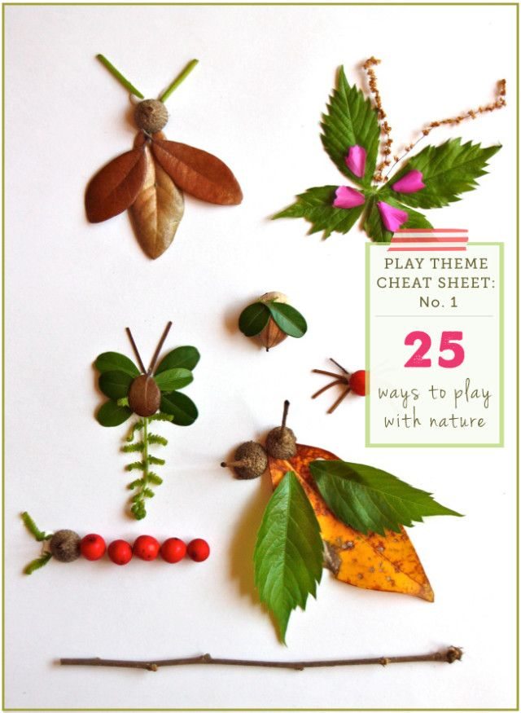

Go on a minibeast hunt in your garden or local park. In Forest School, we encourage the children to look for insects and handle them gently.
- Make a tally chart to see how many of each insect you find
- Count how many legs/wings/antennae/spots the minibeasts have
- Sort them into different groups

Make your own bug hotel! (see other file for instructions)

