Tuesday
First join the google meeting with your class and complete the following tasks.
Circle the correct word.

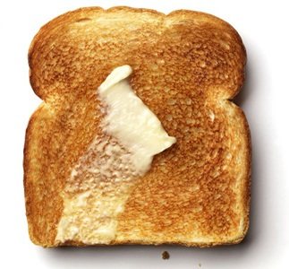

toast tan toad

This Photo by Unknown Author is licensed under CC BY-SA

ship shark shop

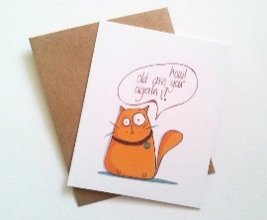
This Photo by Unknown Author is licensed under CC BY-SA-NC
far card cart

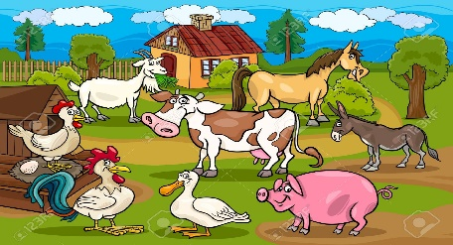
This Photo by Unknown Author is licensed under CC BY-NC-ND
hard barn farm

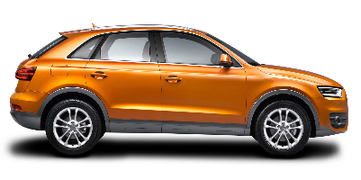
This Photo by Unknown Author is licensed under CC BY-NC
cart lard car

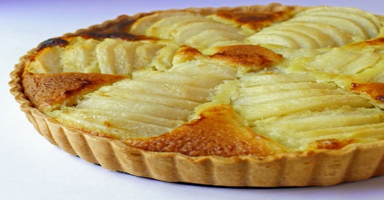
This Photo by Unknown Author is licensed under CC BY-NC-ND
farm tart park

Which word (you have circled) is the odd one out? Why? (toast is the odd one as it does not have the ar digraph)
Write a sentence using one of the words

