Can you label the T-Rex?
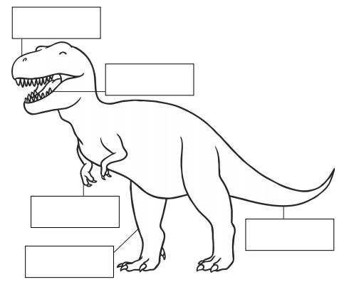

You can add more labels if you need to!

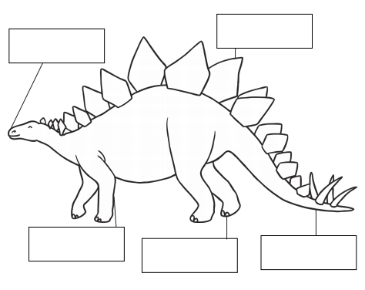
Can you label the stegosaurus?

You can add more labels if you need to!

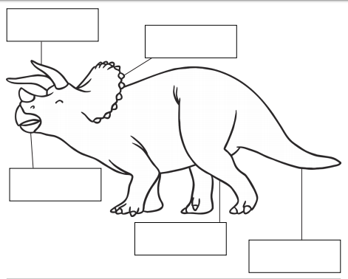
Can you label the triceratops?

You can add more labels if you need to!

