Topic home learning week 4
Here are the Science, Art, History, PE, Music and RE tasks for you to complete this week.

Please do submit your work to your class teacher by Friday.
k.mallon@efs.oxo.sch.uk
s.blake@efs.oxon.sch.uk
l.blackmore@efs.oxon.sch.uk
k.fleet@efs.oxon.sch.uk
e.davies@efs.oxon.sch.uk

Science WALT (we are learning) which materials are absorbent.

In this lesson, we will be learning about which materials are absorbent. See if you can make a prediction about what the word means before you start the video. You will need a piece of paper and a pencil to complete the lesson, but to take part in the experiment, you will need: a sponge or cloth, plastic bag or cup, foil, cardboard or paper, cotton wool or tissue. We would love to see which household objects you have found out are absorbent and what this has taught you.
https://classroom.thenational.academy/lessons/which-materials-are-absorbent-6tk3er

History WALT find out about how the Great Fire started and spread across London.
In this lesson we will be ordering the events from the Great fire of London. Read through the PowerPoint and watch this short cartoon.
Mild - print and sort the attached sheets into the correct order.
Spicy – make your own timeline of the events.
Hot – create your own zig-zag book of the chronological events
of the Great Fire.

During the Great Fire of London

RE – WALT: respond to Bible stories about friendship.

In, R.E. this term we are learning about friendship.
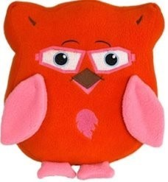Qu: What does it mean to be a good friend? What are some ways you might show friendship?
In today’s lesson, we will be thinking about what Christians believe Jesus did to show friendship.
Qu: Who is Jesus? What do you know about him so far?

Watch these three short stories about Jesus showing friendship.

The Story of Zacchaeus: God's Story: Zacchaeus - YouTube
Stilling the storm: Jesus Calms The Storm - YouTube
Mary, Martha and Lazarus: Martha - Little Bible Heroes animated children's stories - YouTube

After you’ve watched each one, draw and/or write down how Jesus showed friendship in each story. How did he help the people around him? Was it always easy for him to show friendship? Why/why not?

You can use the sheet or make your own.

Art - WALT use sketching techniques to make an observational drawing.
Firstly, watch this helpful clip to help you drawing lines. https://www.youtube.com/watch?v=4y7cllv6ZuE
Here are some 17th Century buildings from the time of the Great Fire of London.
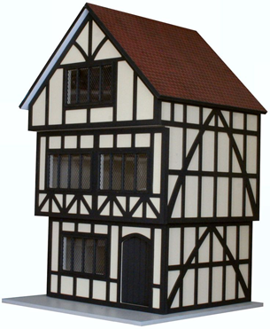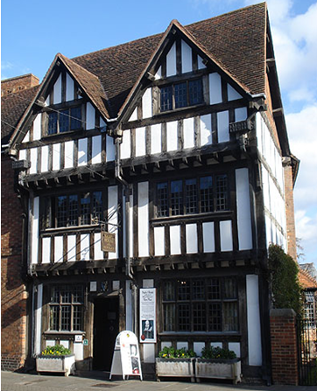

Artists, make careful observations about the details of the buildings. Can you describe the lines used? What patterns can you see?
Can you make an observational drawing of a Tudor house like the examples below?
Challenge – Can you add shading to your sketch to add detail and definition?
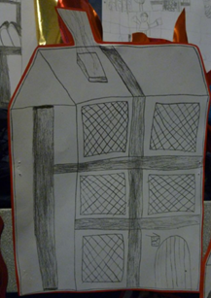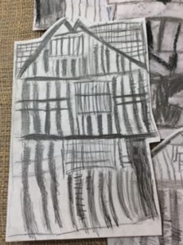
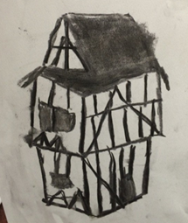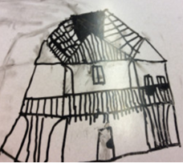

Music – WALT explore the fire through movement and dance.

Listen and join in with part five of Samuel Pepys and the Great Fire of London. In this lesson you will continue to use movement and dance to explore what happened in Pudding Lane.

https://www.bbc.co.uk/teach/school-radio/history-great-fire-of-london-great-fire-spreads/z7ybf4j

P E – WALT keep active.

It is important that while we are in lockdown are still active.
This week complete at least one of Andy’s Wild Workouts that are available on the BBC iPlayer or following the link https://www.youtube.com/watch?v=DqAOMrZkht0&list=PLoOc9M0VgduMnQiJ56Gw5TX7wsGIF7kmv&index=4
Remember that for short active guided breaks you can always ‘Go Noodle’ https://family.gonoodle.com/

