Wider Curriculum – Reading for Pleasure Week,
Week Beginning 1st March 2021

This week, there is a Wider Curriculum lesson for each day that is based around the book we shared in English that day. It may be incorporating music, art, DT or even Science or Geography! We can’t wait to see your work.

Monday – Lost and Found by Oliver Jeffers
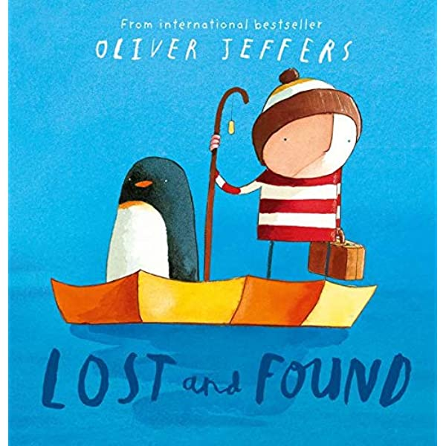
- Listen again to Miss Mallon reading the story of Lost and Found. Can you be ‘Retrieval Rex’ and find out from the story where the penguin is from?
We know that Penguins live in the Southern Hemisphere and particularly in Antarctica. Can you remember where this is on the globe? See if you can tell or show someone at home.
Today’s task is to create your own fact file or poster about an animal from the Southern Hemisphere. This could be a penguin, seal, whale or another animal. See if you can answer the questions below in your fact file.
- Where do they live?
- What do they look like?
- What do they eat?
- Any interesting facts?
- Can you include a picture?

Tuesday – The Tiger Who came to Tea by Judith Kerr
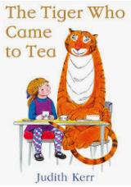
'Hey Tiger!’ Robbie Williams - Karaoke | The Tiger Who Came To Tea | SceneScreen
Click on this link to sing along with a fun song from the Tiger Who Came to Tea movie.
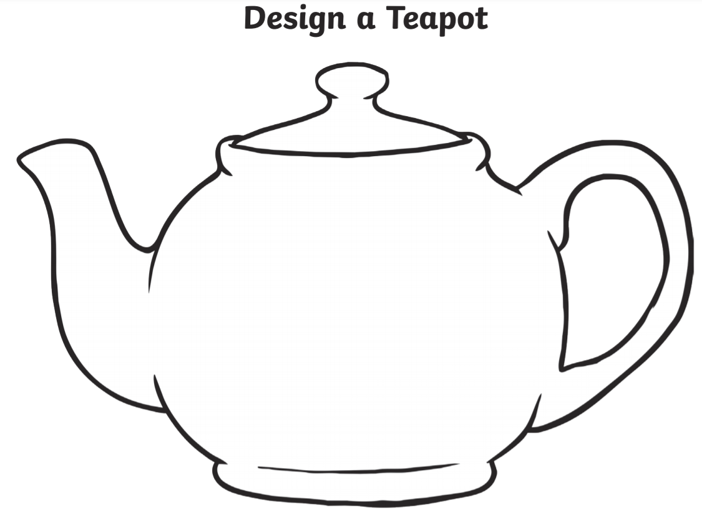
- The tiger drank all of the tea in the teapot! Design a new teapot. You could draw cups and saucers too!
- You could get some teddies or toys and have your own tea party.
- Can you find out what real tigers eat? You could make a fact file about tigers.

Wednesday - Winnie The Witch
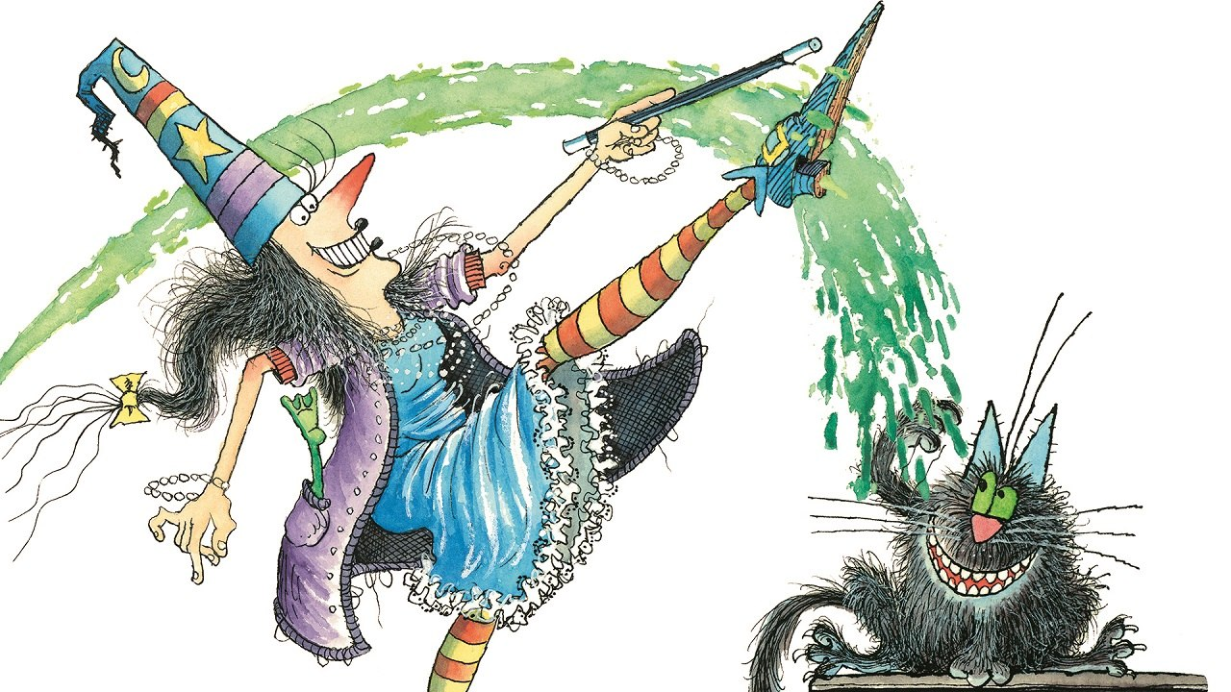
After you have listened to the story (read by Miss Davies) and written your own magic spell, you can have a go at the magic potion science experiment below!
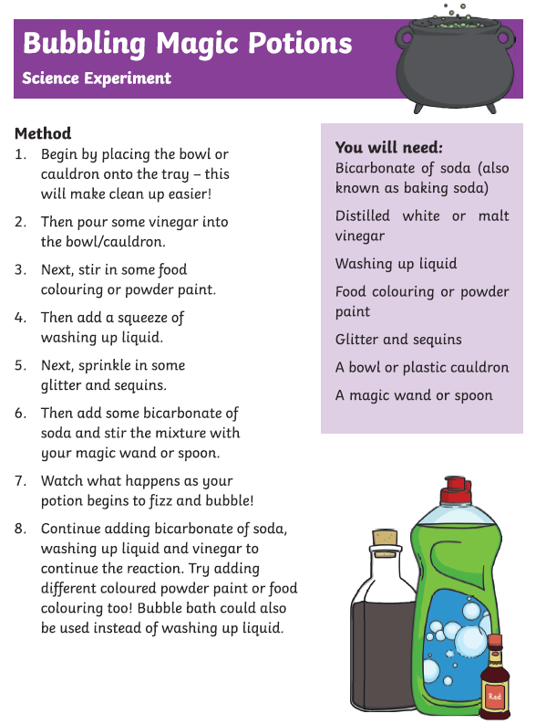
What happens when the ingredients are all mixed together?
What can you see? What words can you use to describe your potion? What colours can you see?

Thursday – Where the Wild things Are by Maurice Sendak
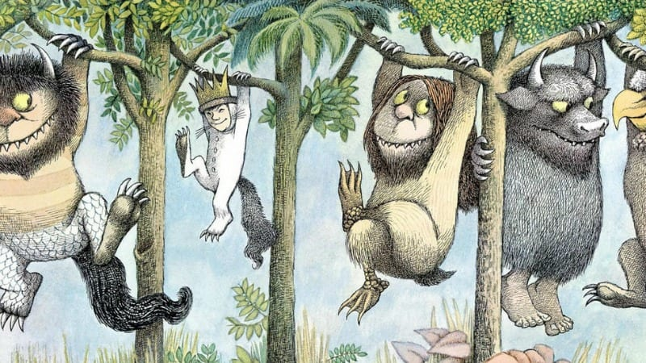
After listening and joining in with to the story ‘Where the Wild Things Are’ we would like you to design and make your own ‘WILD THING’. You can be as creative as you would like. What do you have at home that you could use? When you have finished use your Wild Thing to have your own wild rumpus! You could take this outside to a wild area near you. Do send us photos of all the fun you and your character are having.
- 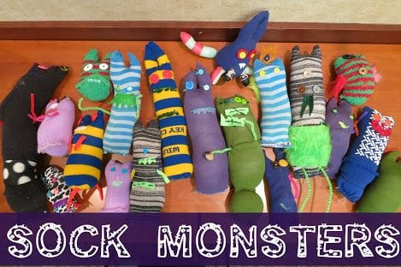 Maybe you have a bag of odd socks that you could use to make a puppet.

- 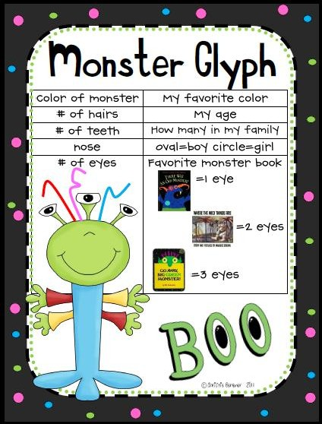 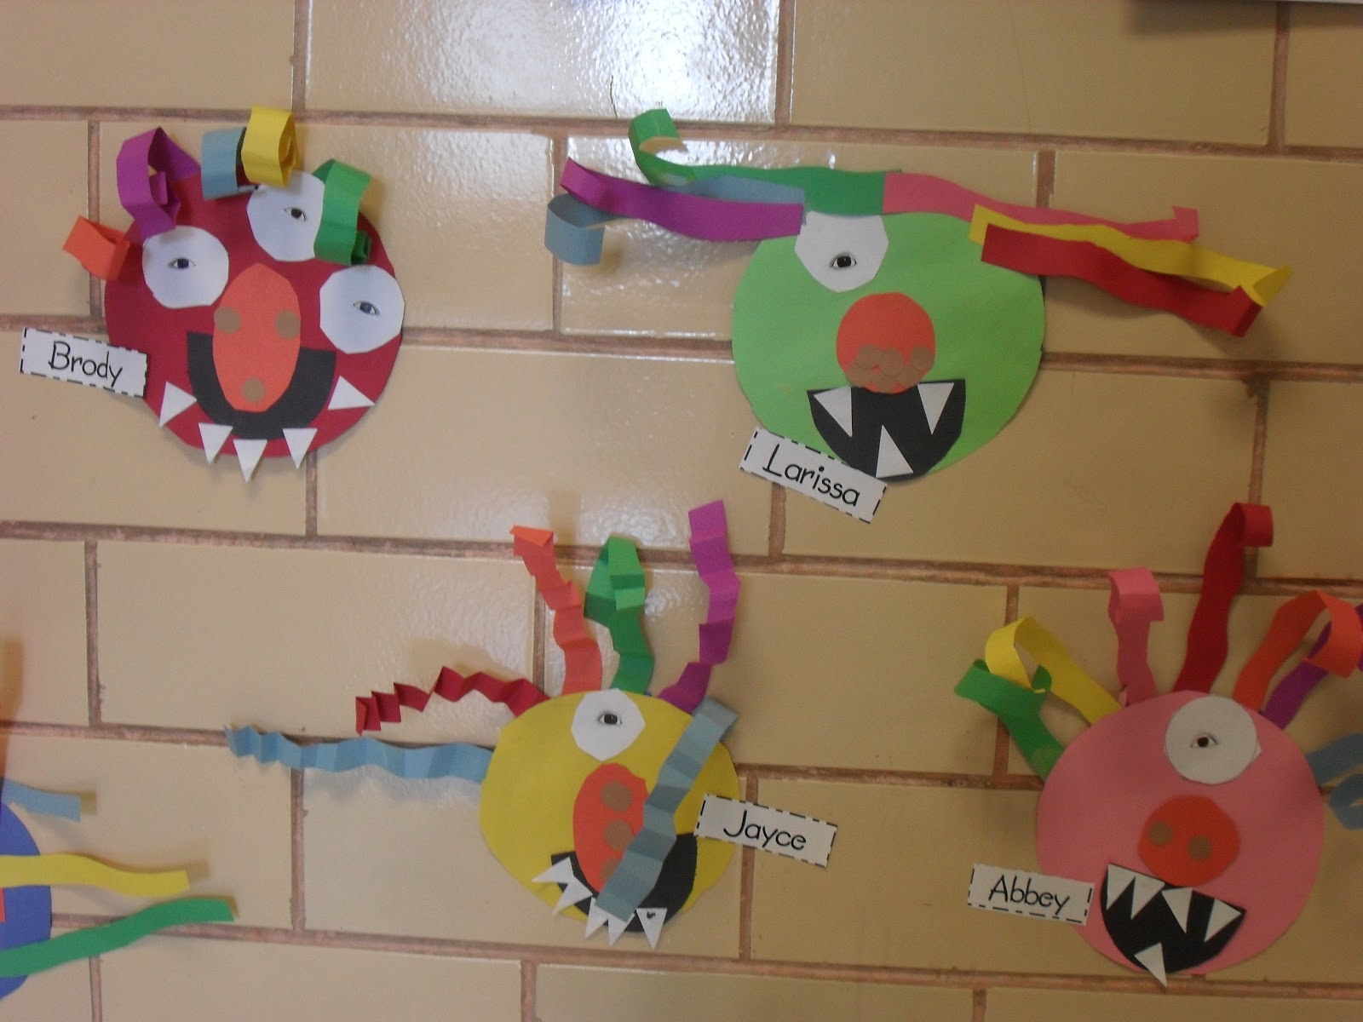If you have coloured paper or card you could follow the instructions to make a Monster Glyph.

- 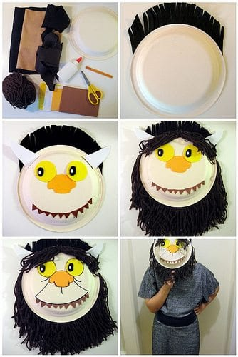 Could you make your own Wild Thing mask by recycling cardboard?
- 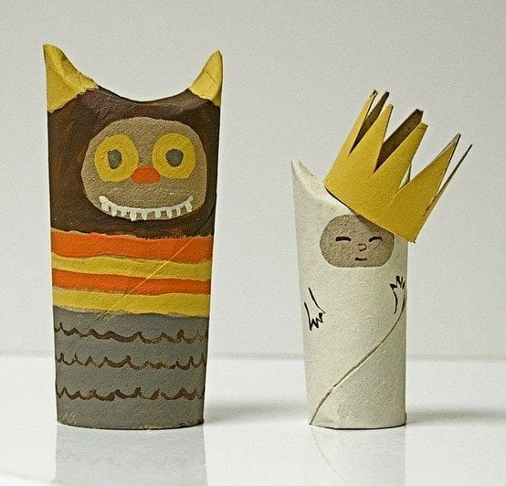Use cardboard tubes and paint to create your own characters. To create the pointy ears, just fold in the tube from each side. Use extra cardboard to create accessories, like the crown shown above.

Friday
