Year 1 Phonics – Week Commencing 27th April
Monday
Read the text below and spot as many words with the /ee/ sound you can find. Then sort them by their sound (see the table below).

ee | ea | ey | e_e | y

Tuesday
Re-read the text from yesterday, then use the /ee/ words from yesterday to be creative. Can you create a board game with them? Do a word hunt around the house/garden? Write them with chalk on the pavement or in sand? Write a story using as many of the words as you can? We would love to see what you come up with on Twitter or via email.

Wednesday
Today, we would like you to add your own /ee/ words (ee, ea, ey, e_e and y) to the table you did on Monday. You may be able to think of some of your own or you may want to look in books at home and hunt for words with the sounds.
Then practise reading the words in your table and choose your favourite to put into a sentence. Remember all of the golden rules a sentence needs.

Thursday – See if you can write the /ee/ words for each picture. You could then even use it as a board game.
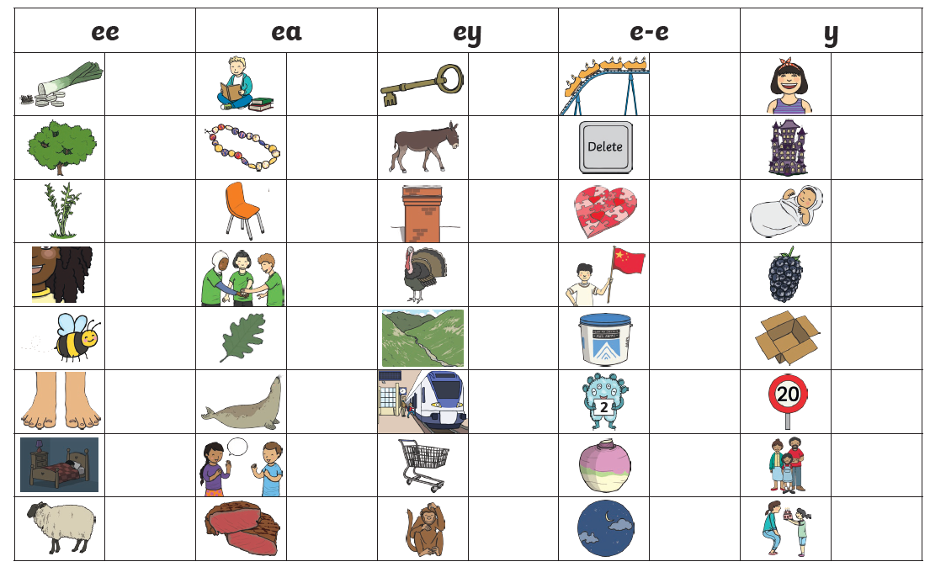

Friday

We would now like you to consolidate your knowledge of the /ee/ sounds from this week.
You can find games on phonicsplay, which you can log in to using the username march20 and the password home.
https://new.phonicsplay.co.uk/resources/phase/5/alt-spellings-ee

There are lots of other phonics games for you to play on the website too.

You can also watch this video to consolidate what we have learnt this week:

https://www.youtube.com/watch?v=WO1ylMaWf0w

