Year 1 Phonics – Week Commencing 30th March
Monday
Read the text below and spot as many words with the /oa/ sound you can find. Then sort them by their sound (see the table below).
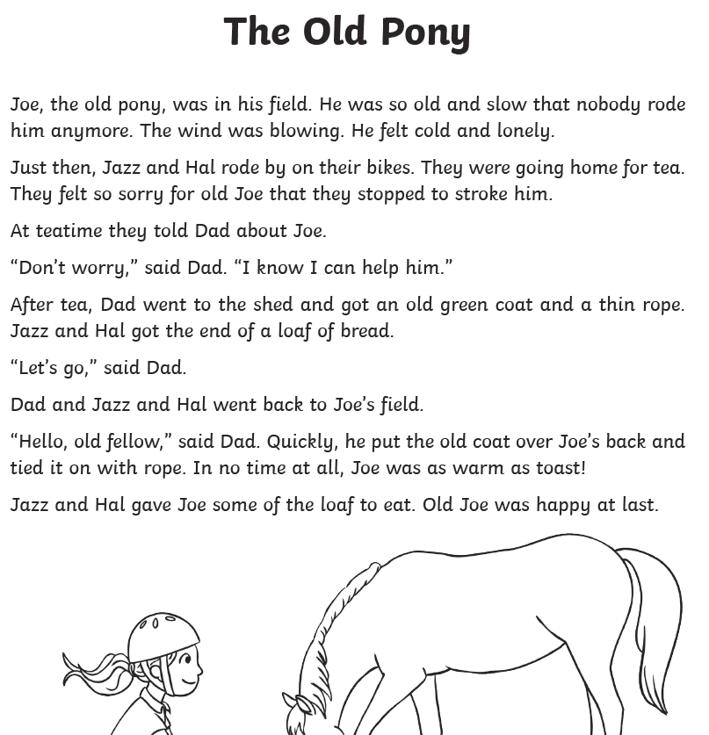

oa | ow | oe | o_e | o

Tuesday
Re-read the story from yesterday, then use the /oa/ words from yesterday to be creative. Can you create a board game with them? Do a word hunt around the house/garden? Write them with chalk on the pavement or in sand? Write a story using as many of the words as you can? We would love to see what you come up with on Twitter or via email.

Wednesday
Read the text below using /ow/ words. Then sort them into a table (like below). See whether you can add any of your own words.

Dear Brown Cow,
Guess what? I found out that a wise
owl can turn its head right round.
I also found out that a clown can be
very loud and make a lot of sounds.
It was loud enough to make me frown!

ou | ow

Thursday – Roll a dice and read the /ow/ words. Then write them into sentences.
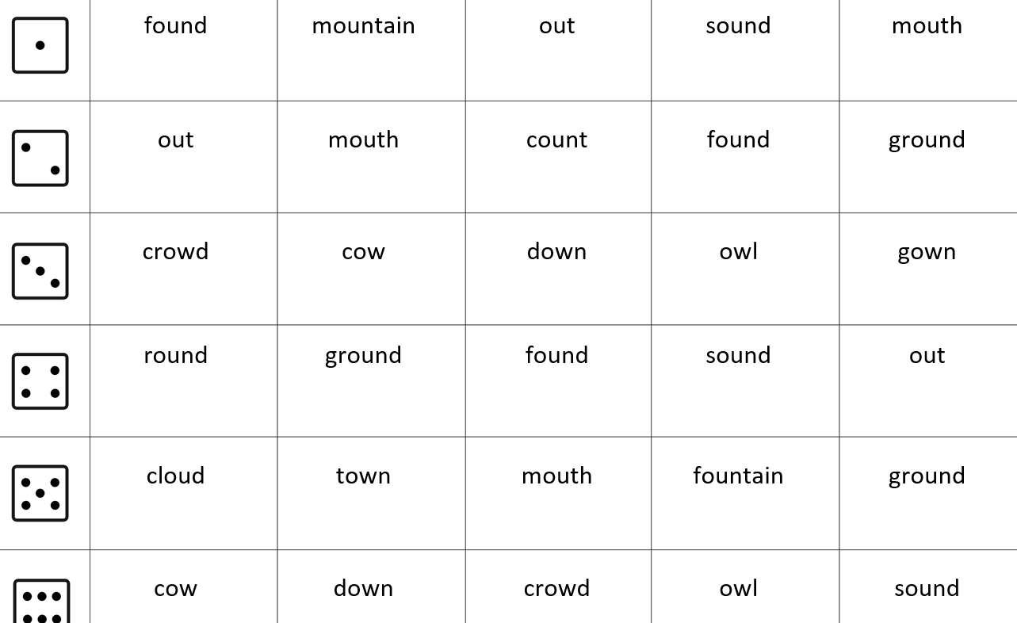

Friday

We would now like you to consolidate your knowledge of the /oa/ and /ow/ sounds from this week.
You can find games on phonicsplay, which you can log in to using the username march20 and the password home.
https://new.phonicsplay.co.uk/resources/phase/5/alt-spellings-oa
https://new.phonicsplay.co.uk/resources/phase/5/alt-spellings-ow

You can also be creative at home in any way you like with the sounds we have revised this week. Again, this could be by putting them into sentences or stories, making your own word hunt or board game, or many more. We would love to see what you come up with via Twitter or email.

