Year 1 Phonics – Week Commencing 4th May
Monday
Read the text below and spot as many words with the /oi/ sound you can find. Then sort them by their sound (see the table below).

The boys were playing in the garden
and asked if they could have some
sweets.
“No, you will spoil your dinner. We
are having oysters!” called Mum.
The boys were digging deep in the soil
when they suddenly found a coil.
“This is a good toy! If we touch it,
it might go boing!” said one of the boys.

oi | oy

Tuesday
Re-read the text from yesterday, then use the /oi/ words from yesterday to be creative. Can you create a board game with them? Do a word hunt around the house/garden? Write them with chalk on the pavement or in sand? Write a story using as many of the words as you can? We would love to see what you come up with on Twitter or via email.

Wednesday
Today, we would like you to add your own /oi/ words (using the oi and oy digraphs) to the table you did on Monday. You may be able to think of some of your own or you may want to look in books at home and hunt for words with the sounds.
Then practise reading the words in your table and choose your favourite to put into a sentence. Remember all of the golden rules a sentence needs.

Thursday – Roll and read with our ‘oi’ and ‘oy’ digraphs.
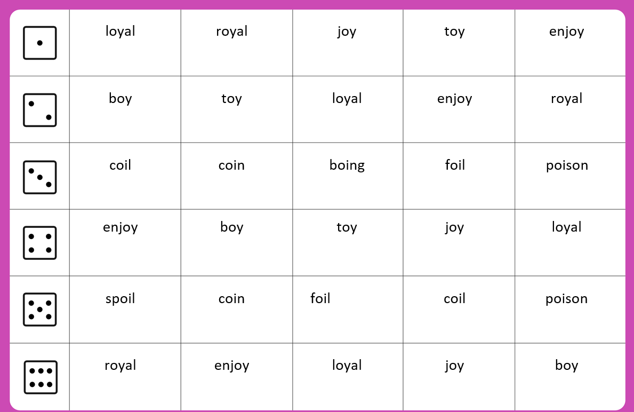

Friday

We would now like you to consolidate your knowledge of the /oi/ sounds from this week.

You can watch and learn the oi spelling rap:
https://www.youtube.com/watch?v=fFZw9dwASI4

You can also find games on phonicsplay, which you can log in to using the username march20 and the password home.
https://new.phonicsplay.co.uk/resources/phase/5/alt-spellings-oi

There are lots of other phonics games for you to play on the website too.

