Year 1 Phonics – Week Commencing 8th June
Monday
Watch the video of Miss Mallon introducing the phonics learning for this week.

Tuesday
Complete this table to practice the different ways of spelling the ‘air’ phoneme. (answers at the end of this document).
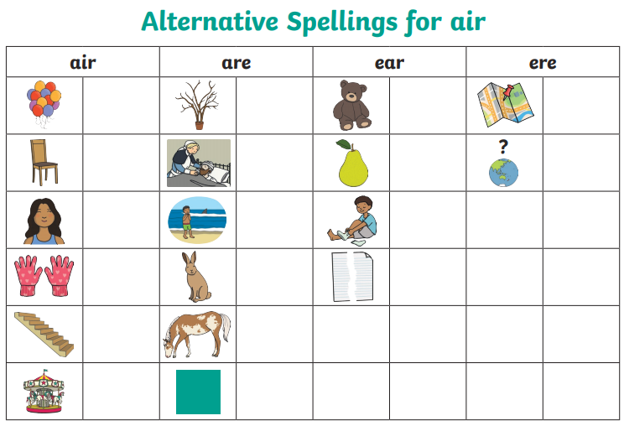
You do not have to print this sheet. You could draw a table or write a list.

You could choose one of the words to write in a sentence.
Don’t forget capital letters, finger spaces and full stops.
Wednesday
The ‘air’ phoneme can be written in different ways. Think carefully about which spelling you need to label these pictures.
(answers at the end of the document).
air are ear ere
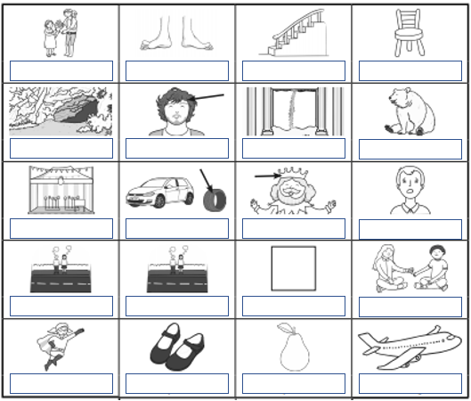
You could choose one of the words to write in a sentence.
Don’t forget capital letters, finger spaces and full stops.
You do not have to print this sheet. You could make a list in your work book or on paper.

Thursday
Read this story and find all of the words that have the graphemes ‘air’, ‘are’, ‘ear’ or ‘ere’ making the sound ‘air’.
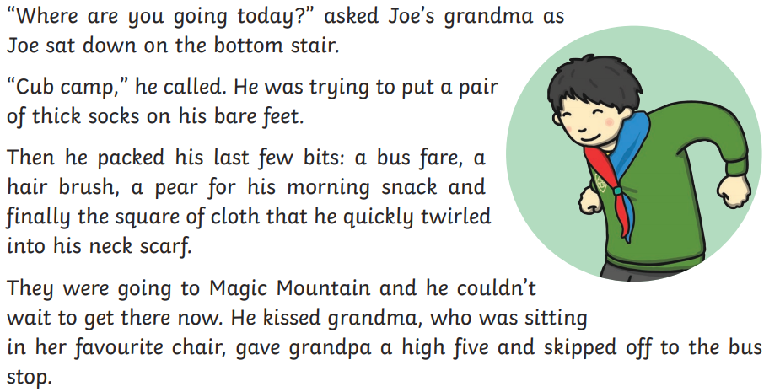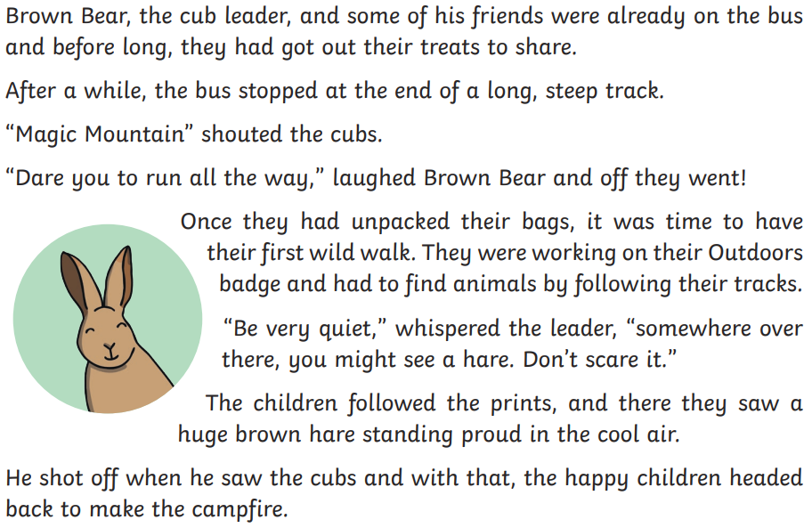
You do not have to print this sheet. You could make a list or tell a grown-up the words you find.

Friday
https://www.phonicsplay.co.uk/member-only/airAltSpellings.html
Use this link
or
go to ‘phonics play’ - username: March20, Password: home
Go to phase 5 and scroll down to ‘investigating alternative spellings /air/’ and work through the phoneme spotter, word sort, best bet activities.

Answers for the activities from Tuesday and Wednesday.
