Year 1 Phonics – Week Commencing 1st June
Monday
Watch the video of Miss Mallon introducing the phonics learning for this week.

Tuesday
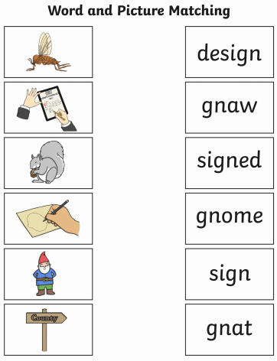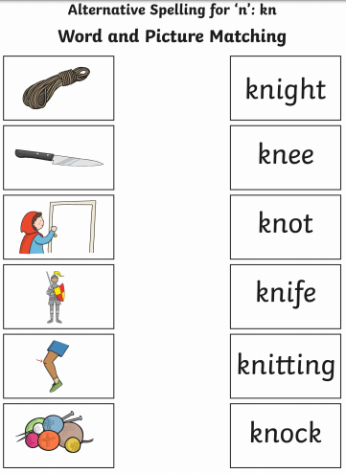
You do not have to print this sheet. You could tell your grown-up the answers.
Tuesday (continued)
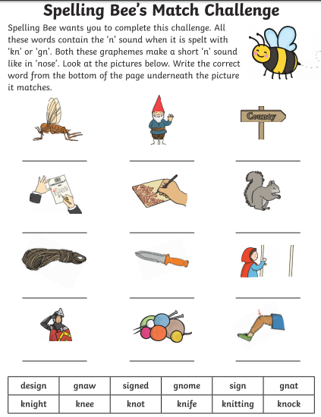
You do not have to print this sheet. You could make a list in your work book or on paper.

Wednesday
You do not have to print this sheet. You could make a list in your work book or on paper.

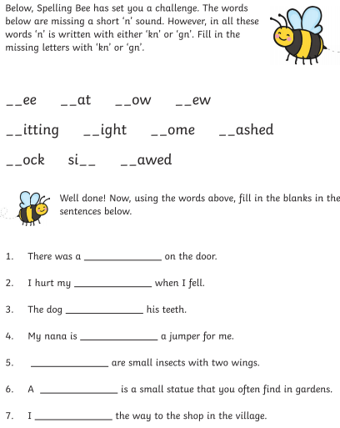

Thursday
You do not have to print this sheet. You could make a list in your work book or on paper.

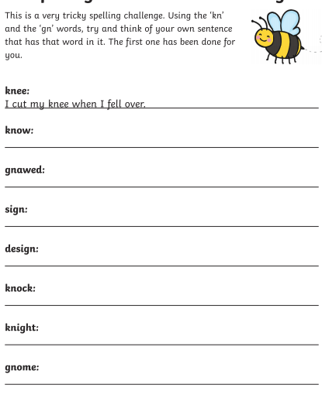

Friday

We would like you to learn to spell the common exception word house. This could be using chalk outside, sand, colourful pens or in any way you like.

When you are sure you can spell house you could try some other Common Exception Word games on the Phonics play website.
https://www.phonicsplay.co.uk/
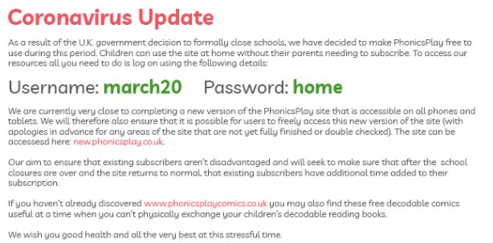

Why not check out some of the other games?

