Year 1 Phonics - Week 4 (25.01.21)
If you are following the videos and playing the games on phonics play you might not want to complete these sheets too. We want to provide a range of activities on the screen and on paper.
You do not have to print these sheets. You could write your answers on a piece of paper or point to the answers on the screen. Answers are at the end of the document.

Here are this week's spellings, learn them for a test on Thursday. 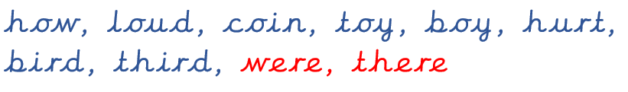
Monday 25th January
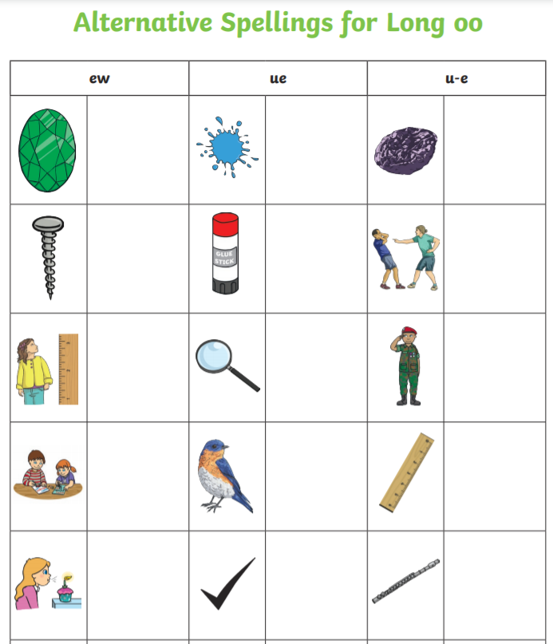

Tuesday
Read this postcard – how many different ways of spelling /ee/ can you find?

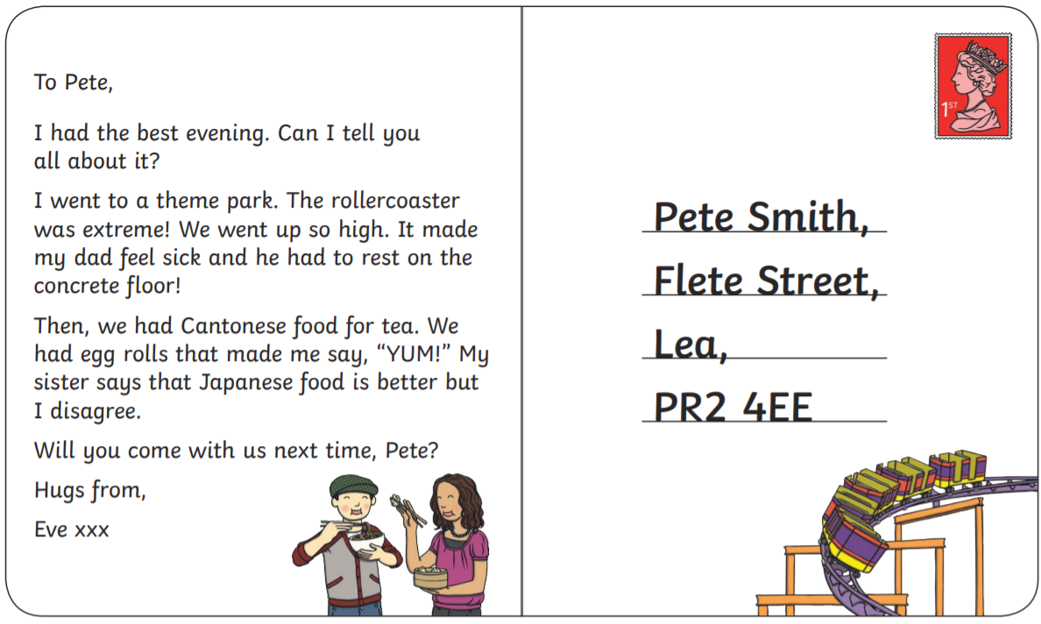

Wednesday
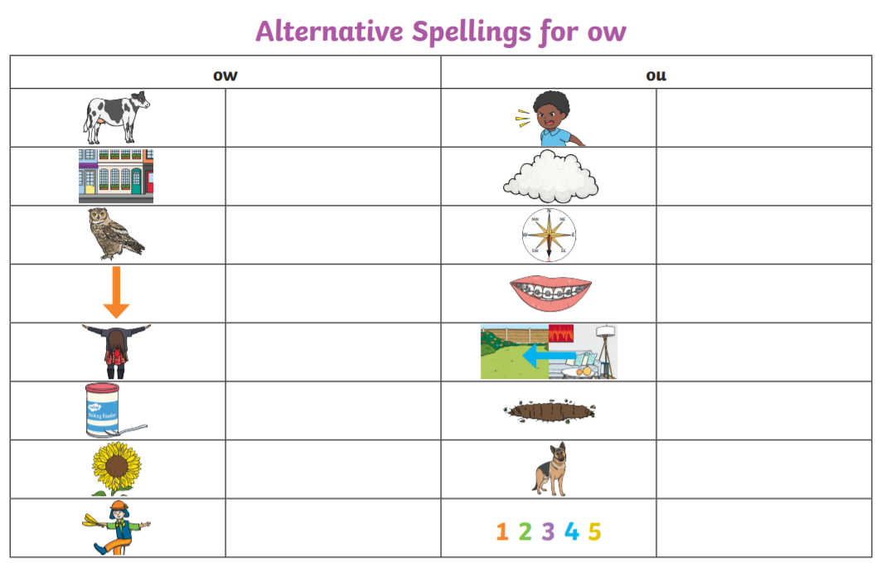

Choose a word from each column to write in a sentence.

Thursday
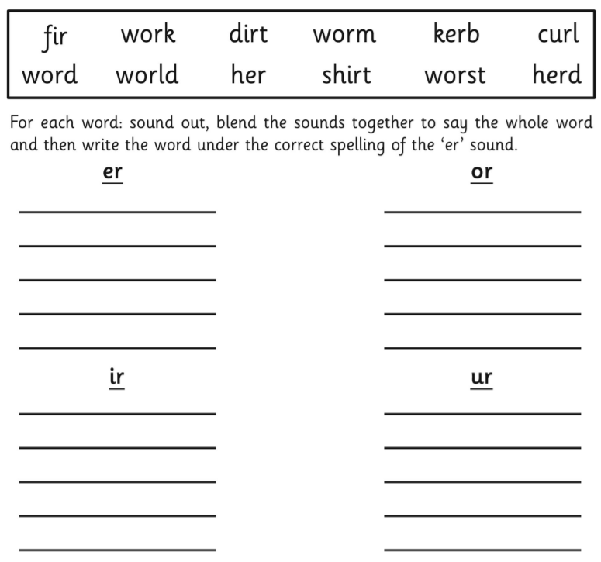

ANSWERS
Monday
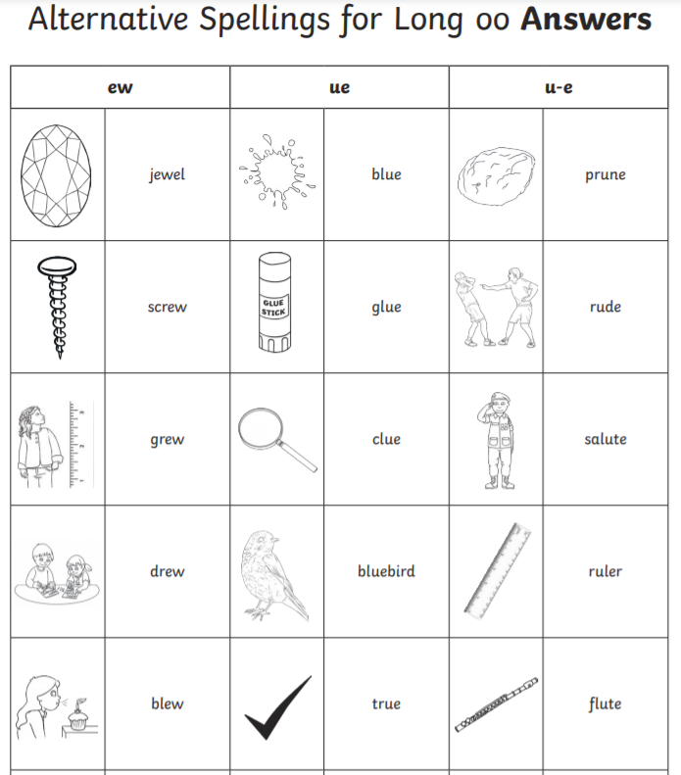
Wednesday
