Year 2 Phonics – Week commencing 11th May
Monday
This week, we are going to be thinking about when the letter ‘o’ makes the /u/ sound. To start with, read all of the words below and then sort them into words that make the /o/ sound and words that make the /u/ sound. You could do this by drawing your own table or using two different colours.

Pop
Brother
Song
Love
Dolphin
Robin
Doll
Son
Moth
London
Come
Sock
Soft
Wonder
Other

Tuesday

Re-read the words from yesterday and choose two of the words that have the /u/ sound (for example, brother) to put into a sentence.

Don’t forget all of the things that make a successful Year 2 sentence! Capital letters and full stops, checking our spellings, conjunctions, exciting sentence openers and powerful adjectives.

Wednesday

Watch the story below

https://www.youtube.com/watch?v=TTpHoiSobjE

Write down all of the /u/ words as you go along and then see if you can create a game or quiz to play at home using the words.

Thursday

There are lots of spelling mistakes in the text below. Can you change them all to the correct spellings?

Maybe you could even then write your own diary entry about what you have done today, using some of our words of the week.

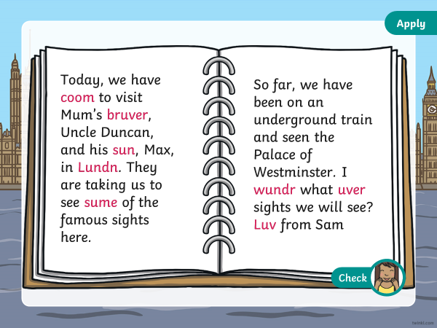

Friday
Practise your common exception words. You may want to choose the ones you find the trickiest. You could practise them by writing them with colours, in chalk outside, making a game with them, putting them into your own story, or in any way you like.

