Year 2 Phonics – Week commencing 20th April
Monday
Sort the words below into the different ways of spelling the ‘ee’ sound. You may want to do this by printing and cutting them out, by drawing your own table, or in any other creative way you like.

Donkey
Freezing
Sea
Squeak
Money
Key
Beast
Green
Turkey
Messy
Funny
Beach
Valley

Tuesday
Remind yourself of the words we looked at yesterday and all the different ways of spelling the /ee/ sound.

Write a sentence about this picture using as many of our words as you can.
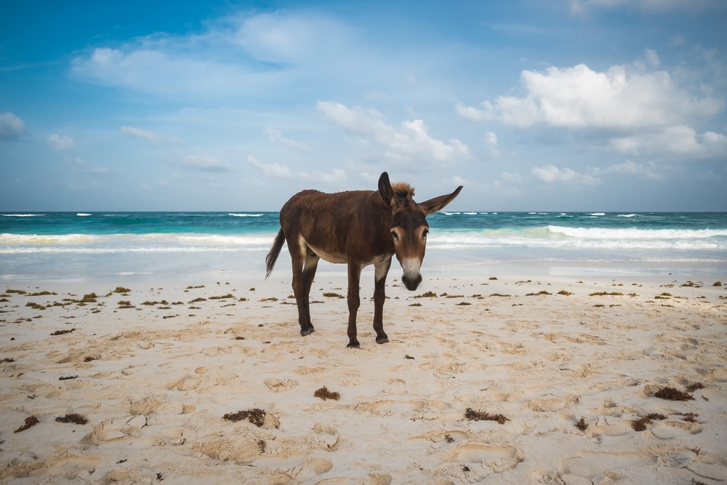

Wednesday
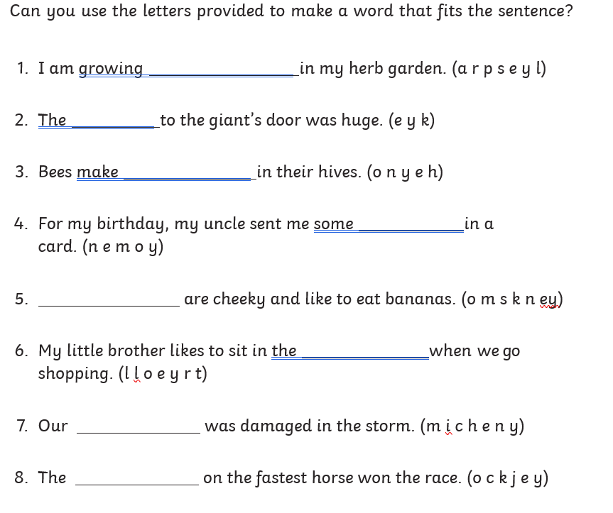

Thursday

See if you can think of other words that have the /ee/ sound spelt ‘ey’. You unscrambled some from yesterday – can you add more to the list?

Find some books at home and use these to help you hunt for more words using this sound.

Friday
Time to be creative using our words from this week! You may like to create your own picture or poster using the words, use chalk to write them outside, write a story using the words…it is completely up to you. We would love to see what you come up with through email or twitter.

