Year 2 Phonics – Week commencing 27th April
Monday
This week, we are going to be thinking about the /or/ sounds, particularly when the letter ‘a’ makes the /or/ sound. Sort the words below into the different ways of spelling the ‘or’ sound. You may want to do this by printing and cutting them out, by drawing your own table, or in any other creative way you like.

Walk
Fork
Daughter
Chalk
Talk
automatic
Draw
For
Laundry
Claw
author
Wall
Pork
Short
Always
Ball

Tuesday
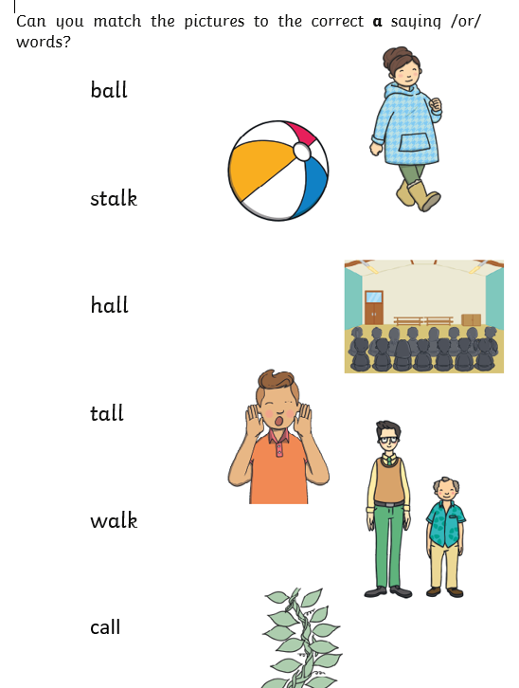

Wednesday

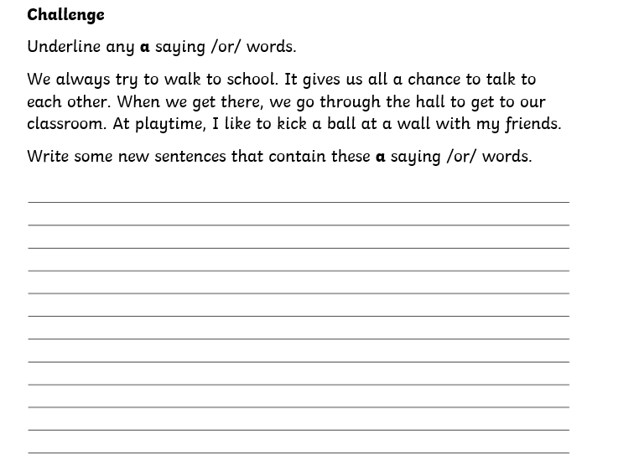

Thursday
Write some perfect sentences using the words we have focused on so far this week.

Remember that a successful sentence needs:
- A capital letter and full stop
- Finger spaces
- Check our spellings
- Cursive handwriting

A successful sentence may have:
- Conjunctions (and, but, because, when)
- Exciting sentence openers (Adverbs? Telling us when or where something happened?)
- Powerful adjectives

Friday
Time to be creative using our words from this week! You may like to create your own picture or poster using the words, use chalk to write them outside, write a story using the words…it is completely up to you. We would love to see what you come up with through email or twitter.

