Year 2 Phonics – Week commencing 30th March
Monday
In school, we have been doing lots of learning about suffixes. We are going to consolidate some of this learning this week. Today, read the story below and write down any words you can find using the -er, -est and -y suffixes in CVCC words. Can you add any of your own words?
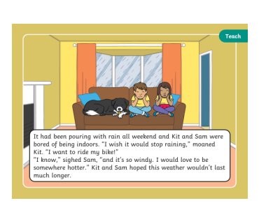

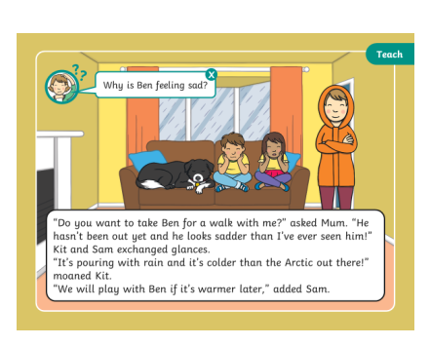
Tuesday
Remind yourself of the words with suffixes that we looked at yesterday.
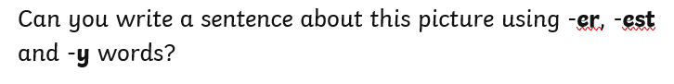

Wednesday
This week we have looked at CVCC words, such as wind or calm, that we add suffixes to. They can change to windy and calmest, for example, but the root word doesn’t change.
Today we are going to look at CVC words and what changes about the root word when we add a suffix.
Can you explain to someone at home what happened here?

Pop -> Popped
Hop -> Hopping

See if you can now change the other words below to add -ed and -ing suffixes.
Rap
Hug
Jog
Fit
Hum

See if you can think of any other words where this spelling pattern is the same.

Thursday – Change the words then complete the challenge. 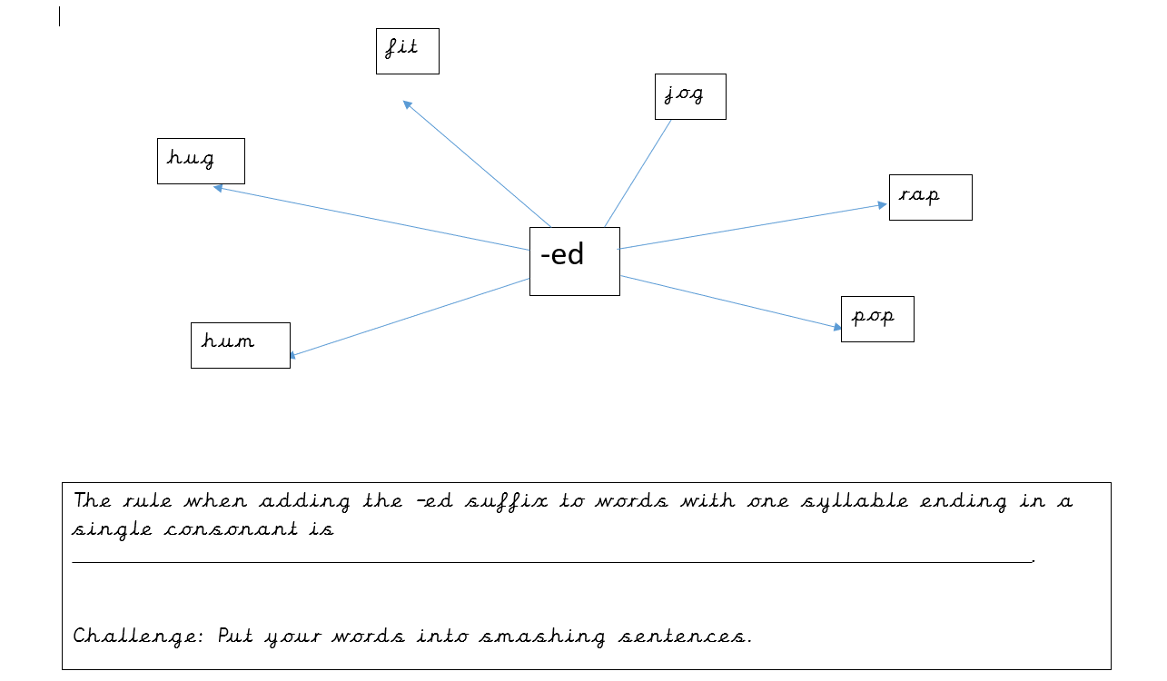
Friday

Today is your chance to be creative with what we have learnt this week! We would like you to use the words with suffixes we have worked on to create something. It could be a story, a comic strip, a board game, a word hunt in your house or garden…the possibilities are endless!
We would love to see what you come up with via Twitter or email.

