Year 2 Phonics – Week commencing 6th July
Monday
This week, we are learning to read and spell homophones.
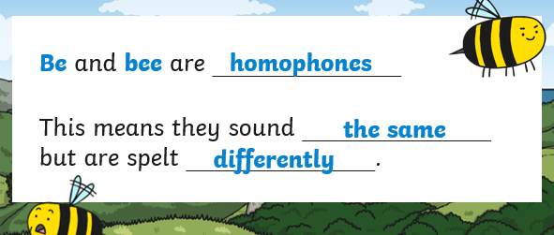
Watch Miss Mallon’s video and follow the instructions.
Tuesday
Practise spelling the exception word everybody You could practise it by writing the word with colours, in chalk, making a game with it, putting it into your own sentence or story, or in any way you like.
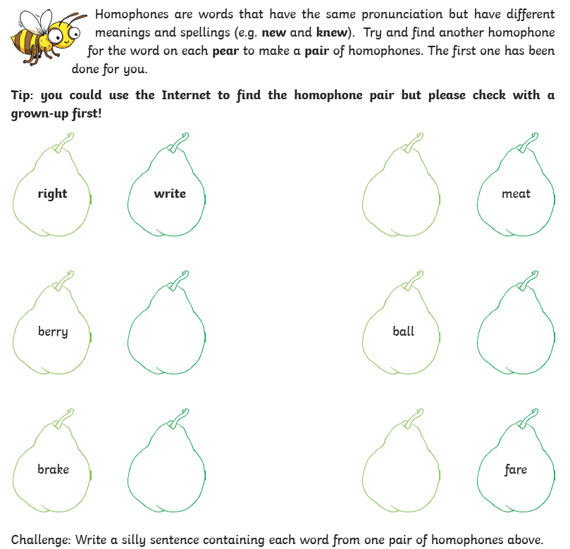

Wednesday
Practise spelling the exception word even. You could practise it by writing the word with colours, in chalk outside, making a game with it, putting it into your own sentence or story, or in any way you like.
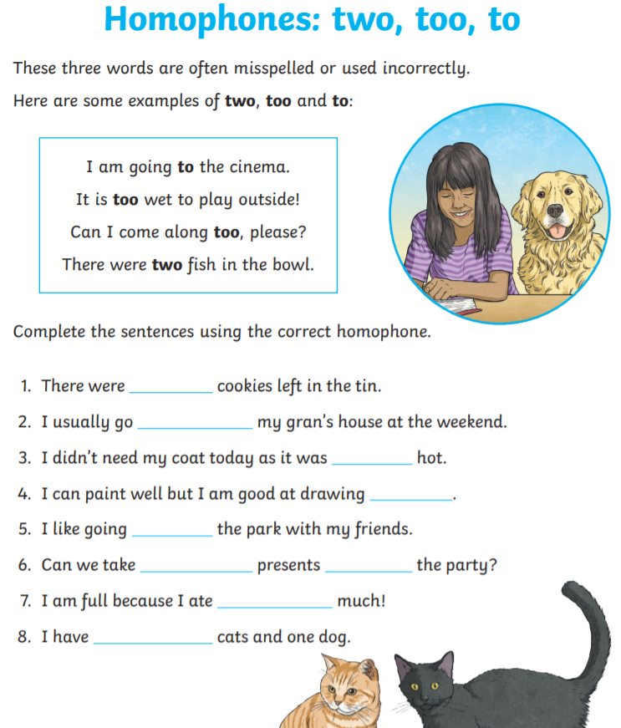

You do not need to print this page. You could write a list in your workbook or on a piece of paper.

Thursday
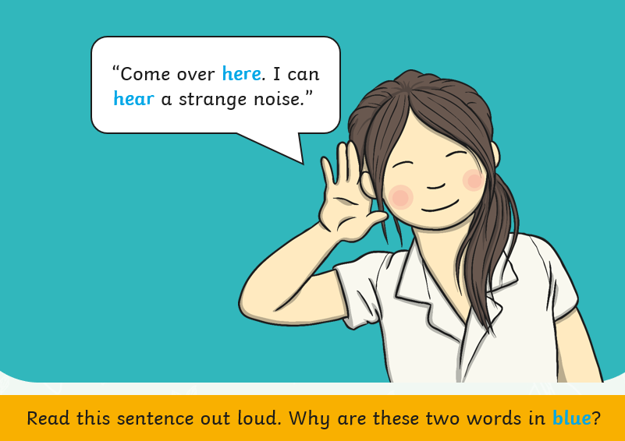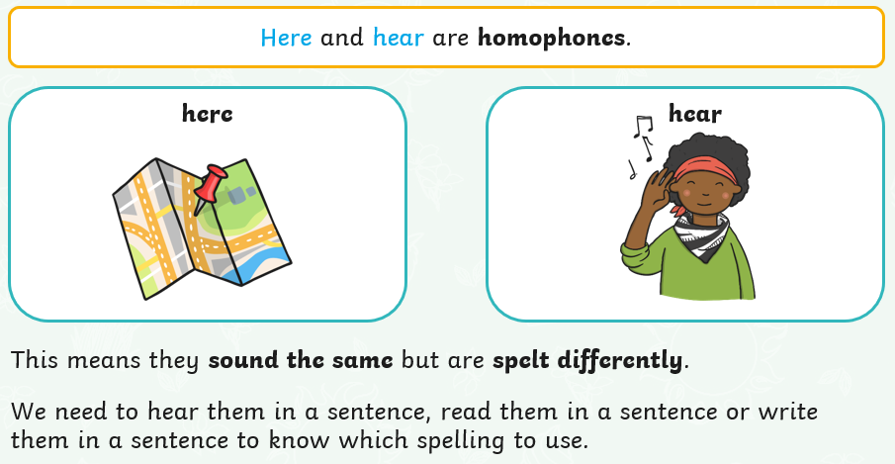
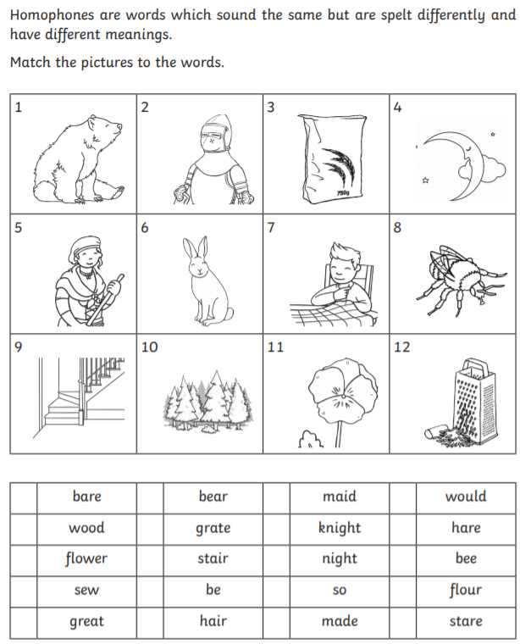
You do not need to print this page. You could write a list in your workbook or on a piece of paper.

Friday

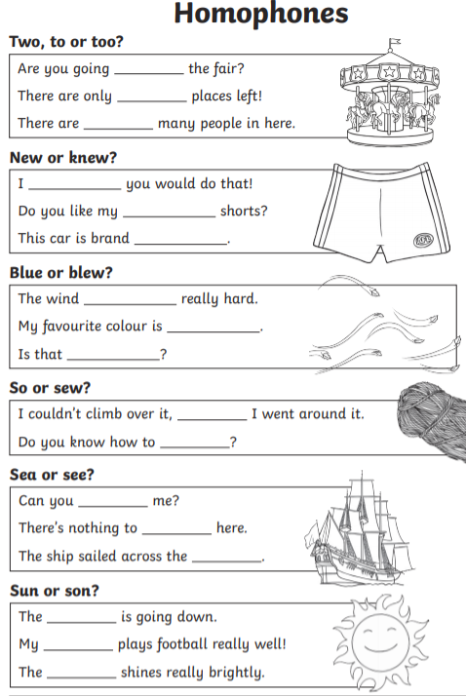
You do not need to print this page. You could write a list in your workbook or on a piece of paper.

Friday (cont.) You could do this wordsearch if you want more practice
