Year 2 Phonics – Monday 28th July
Compound words are formed when two or more words are joined together to create a new word that has an entirely new meaning. For example, “sun” and “flower” are two different words, but when joined together, they form another word, Sunflower. You could watch this video to find out more: https://www.bbc.co.uk/bitesize/topics/zcgv39q/articles/z38t6fr
You do not need to print this sheet. You could write your answers on a sheet of paper.
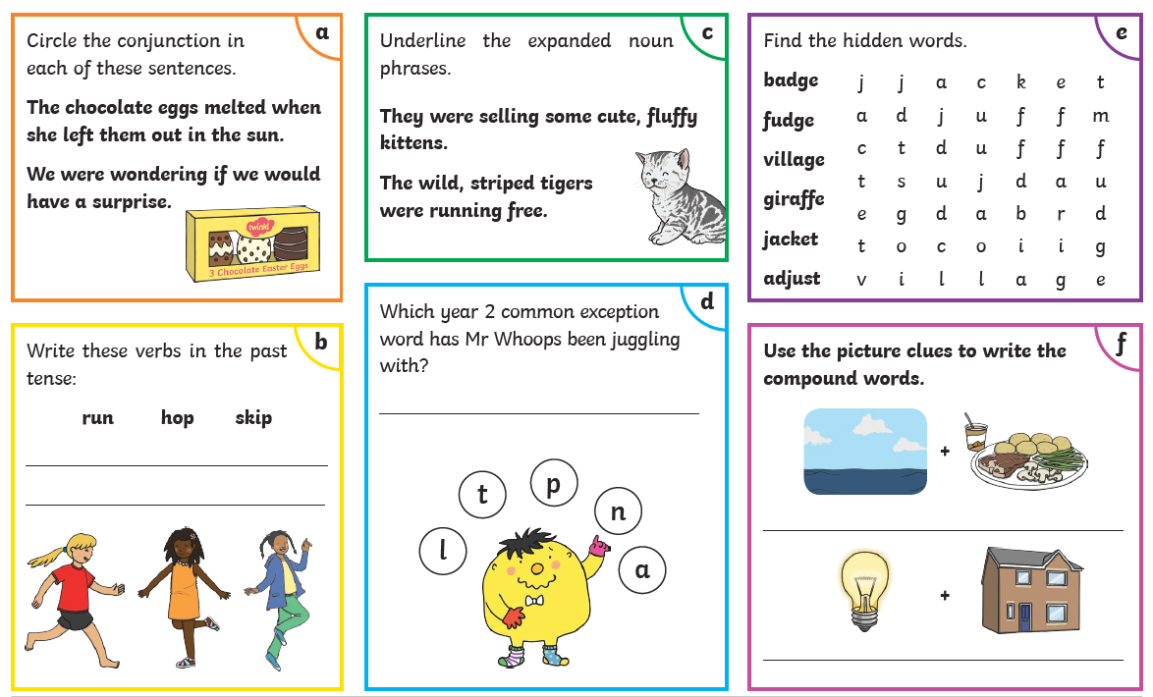
Year 2 Phonics – Tuesday 29th July.
A homophone is a word that is pronounced in the same way but has a different spelling or meaning. You can find out more about homophones in this video https://www.youtube.com/watch?v=gK82V1yGk9w
You do not need to print this sheet. You could write your answers on a sheet of paper.
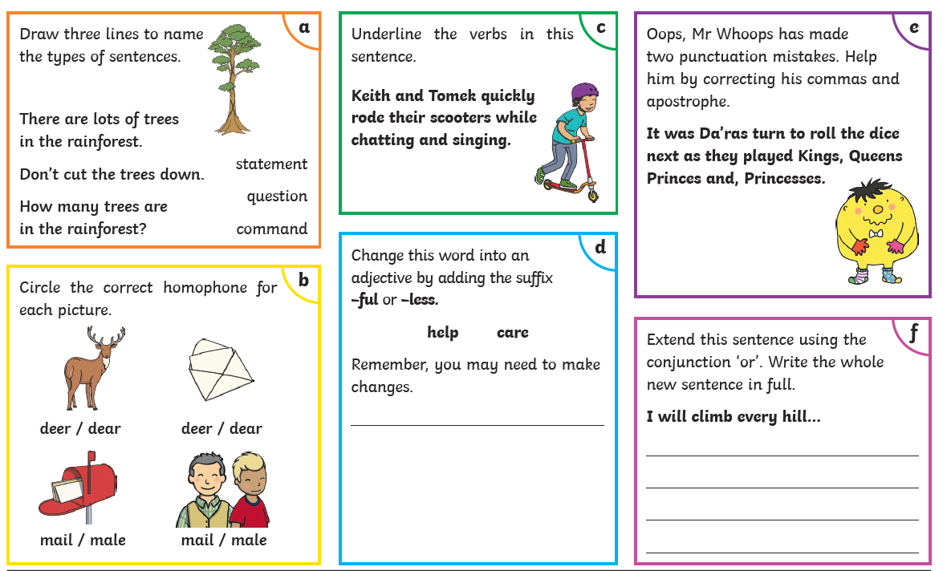
Year 2 Phonics – Wednesday 30th June.
We need to use expanded noun phrases to add interest or detail. You can find out more about them at: https://www.youtube.com/watch?v=XhwjS4zEZDM
You do not need to print this sheet. You could write your answers on a sheet of paper.
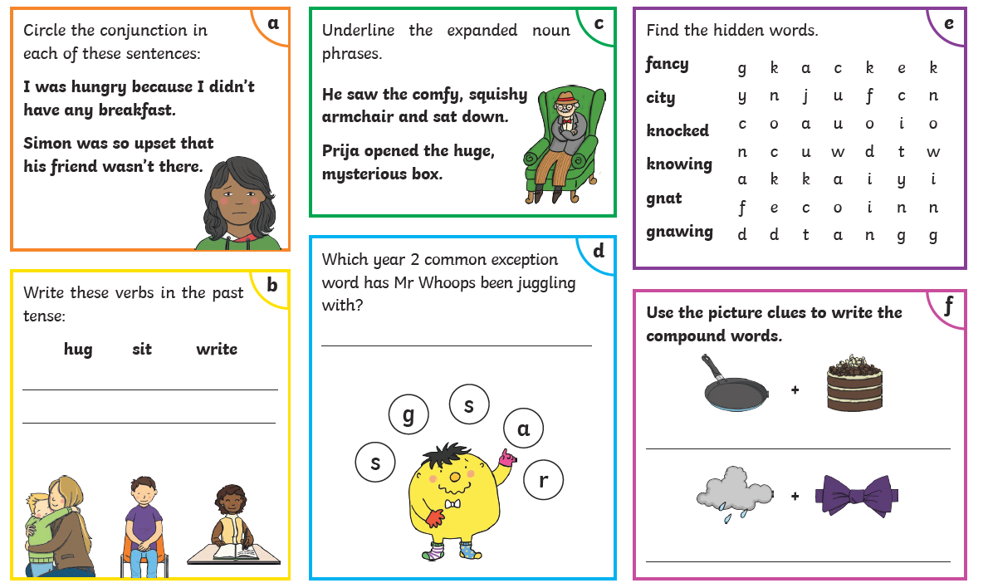
Year 2 Phonics – Thursday 1st July
Contractions can be used to join two separate words to create one shorter word. We do this by using an apostrophe ( ' ) to show that we have left out some letters when joining words together. For example, you can join the words you and are together to create the word you're .
Watch this video for more explanation. https://www.youtube.com/watch?v=sEGPVtxesjM
You do not need to print this sheet. You could write your answers on a sheet of paper.
