Year 2 Phonics – Week commencing 1st June
Monday
This week, we are learning to add the suffixes -ness and -ment to words. We will be learning how these suffixes change the meaning of the root word, and learning how to spell them.
Watch Miss Mallon’s video and follow the instructions.

Tuesday
Practise spelling the exception word who. You could practise it by writing the word with colours, in chalk outside, making a game with it, putting it into your own sentence or story, or in any way you like.

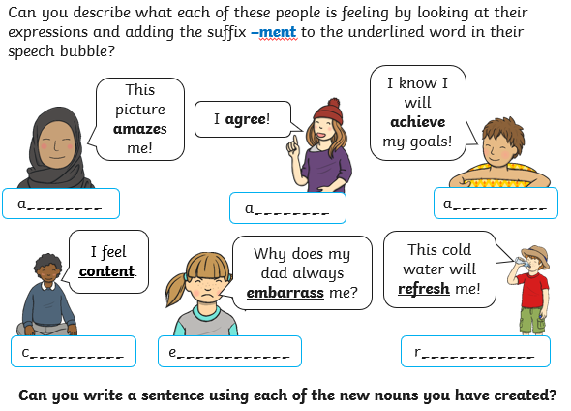
You do not need to print this page. You could write a list in your workbook or on a piece of paper.

Wednesday
Practise spelling the exception word whole. You could practise it by writing the word with colours, in chalk outside, making a game with it, putting it into your own sentence or story, or in any way you like.

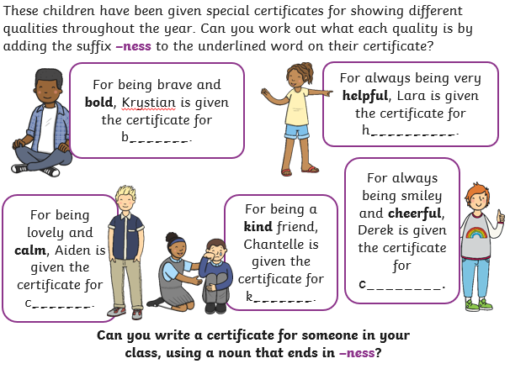

You do not need to print this page. You could write a list in your workbook or on a piece of paper.

Thursday
Practise spelling the exception word any. You could practise it by writing the word with colours, in chalk outside, making a game with it, putting it into your own sentence or story, or in any way you like.

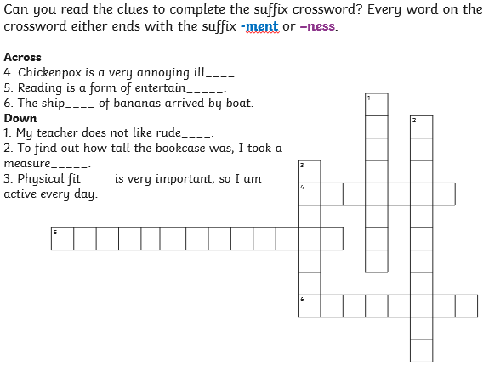

You do not need to print this page. You could write a list in your workbook or on a piece of paper.

Thursday

Friday
Today we will find out that sometimes we have to change the root word before we add the suffix ‘ment’ or ‘ness’
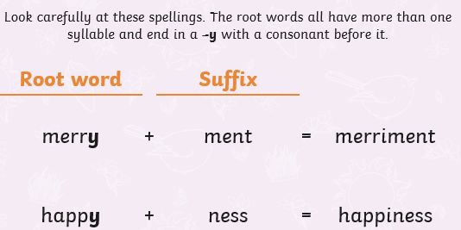
Write out these words and add the suffix – ness
ill
fit
happy

Write out these words and add the suffix – ment
enjoy
argue
merry

Choose a word to write a perfect sentence. Don’t forget all of the things that make a successful Year 2 sentence! Capital letters and full stops, checking our spellings, conjunctions, exciting sentence openers and powerful adjectives.

