Year 2 Phonics – Week commencing 8th June
Monday
This week, we are learning to spell words with/wor/ saying /war/ and /wur/, and /qua/ saying /quo/
Watch Miss Mallon’s video and follow the instructions.

Tuesday
Practise spelling the exception word many. You could practise it by writing the word with colours, in chalk outside, making a game with it, putting it into your own sentence or story, or in any way you like.

Read this diary entry from Florence Nightingale. Can you find the words containing /war/ saying /wor/?
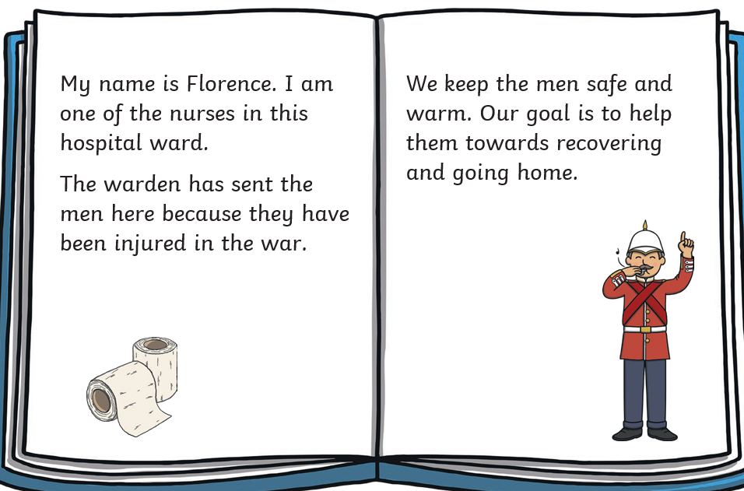
You do not need to print this page. You could write a list in your workbook or on a piece of paper.

Match the words and pictures.
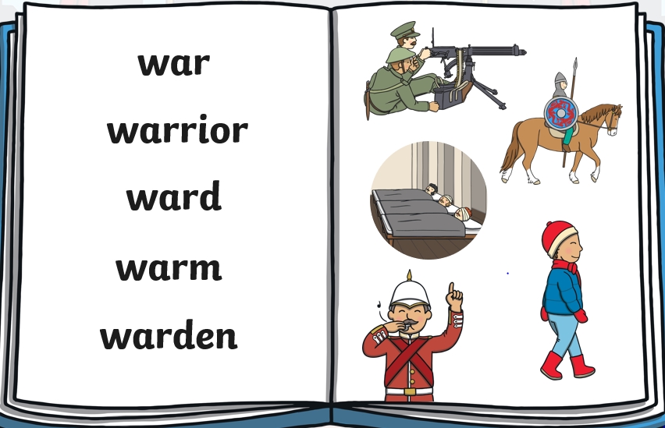
Choose one of these words to write in a perfect sentence.

Wednesday
Practise spelling the exception word clothes. You could practise it by writing the word with colours, in chalk outside, making a game with it, putting it into your own sentence or story, or in any way you like.

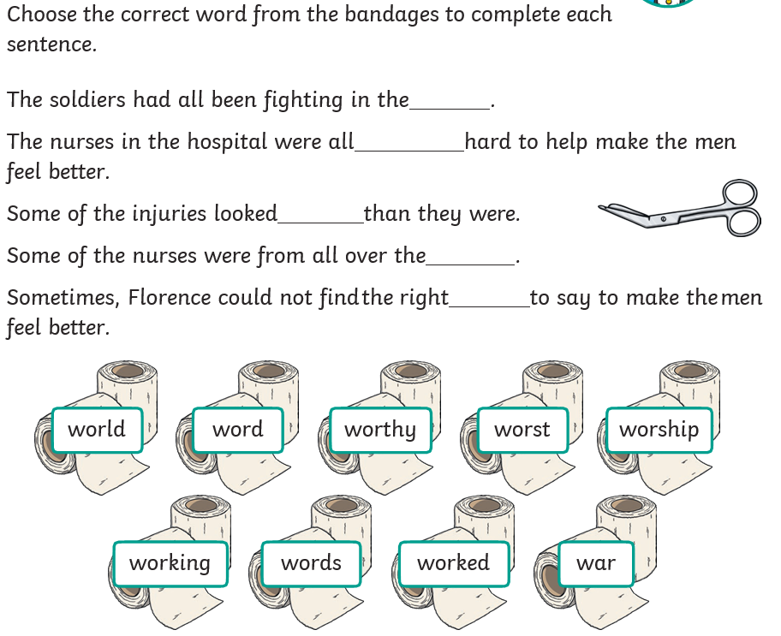

You do not need to print this page. You could write the sentences in your workbook or on a piece of paper.

Write a label for these pictures. Be careful, do you need /wor/ or /war/?
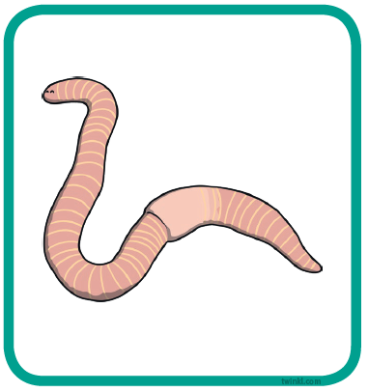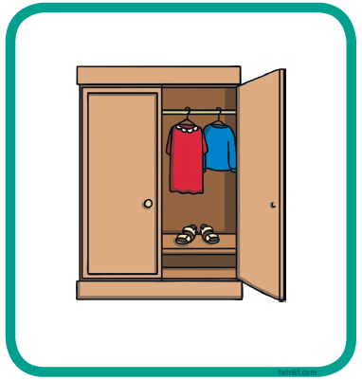

Thursday
Practise spelling the exception word busy. You could practise it by writing the word with colours, in chalk outside, making a game with it, putting it into your own sentence or story, or in any way you like.

In some words, qua can make the /quo/ sound. This can be at the beginning or in the middle of words.
quality
squabble

Here are some words with the /qua/ saying /quo/ missing. Fill in the missing sound and read the word aloud.

__________ntity, s________t, s________d, s_______ash, ________rter, ________rrel.

Choose a word to write a perfect sentence. Don’t forget all of the things that make a successful Year 2 sentence! Capital letters and full stops, checking our spellings, conjunctions, exciting sentence openers and powerful adjectives.

You do not need to print this page.
You could write a list and a sentence in your workbook or on a piece of paper.
Thursday

Friday
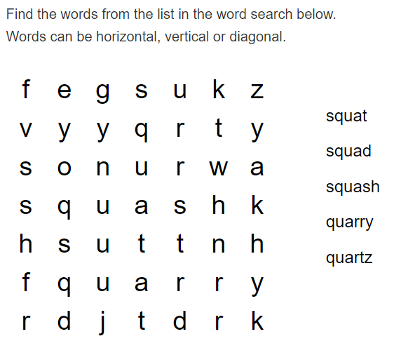
You do not need to print this page. You could show your grown-up when you have found the words.
Choose a word to write a perfect sentence. Don’t forget all of the things that make a successful Year 2 sentence! Capital letters and full stops, checking our spellings, conjunctions, exciting sentence openers and powerful adjectives.

